DRAFT NATIONAL FLOOD PREPAREDNESS AND RESPONSE PLAN FOR NIGERIA

INTER-MINISTERIAL COMMITTEE ON THE DEVELOPMENT OF THE NATIONAL FLOOD EMERGENCY PREPAREDNESS AND RESPONSE PLAN
26TH JANUARY 2021

EMERGENCY PREPAREDNESS AND RESPONSE PLAN

Executive Summary
Floods are without doubt among the most devastating natural disasters, striking numerous eco-climatic regions in the country annually. During the last decades the trend in flood damages has been growing exponentially. The development of hydrological forecasting, and warning systems as well as preparedness, prevention, response and mitigation measures are therefore essential elements in regional and national flood emergency strategies. On a sad but realistic note, the government and people of Nigeria must all come to realize that flood cannot be avoided. It is therefore important that we set all conditions to mitigate the consequences of flood, prepare for its occurrence, respond to it when it happens and recover from it after it has happened; in essence, we must learn how to manage floods in Nigeria. The need for an Integrated Flood Risk Management System that would leverage on technology and new innovations such as flood mapping, flood early warning systems, etc. can never be overemphasized. Hence, the purpose of this “National Flood Emergency Preparedness and Response Plan (NFEPRP) for Nigeria” is to provide strategic guidance in a systematic and sequential manner for managing floods anywhere in Nigeria in a coordinated manner. The objective of this Plan is “to increase political and stakeholders’ commitment and participation in the governance of flood risks reduction” at all levels. This will therefore “improve local capacities for the identification, mitigation, prevention, response, assessment and monitoring of flood risks”.
The Plan was developed with the consideration of the four phases of Disaster Management Cycle (Mitigation, Preparedness, Response and Recovery) as the most effective means of dealing with perennial flood in Nigeria. In the Mitigation phase, all stakeholders would be engaged and lead in activities that would significantly reduce or eliminate flood risks before the floods occur and in the Preparedness phase, the stakeholders will collectively carry out responsibilities to prepare for any anticipated floods. When the anticipated floods occur, the Response phase is activated to involve all stakeholders to provide immediate assistance such as conducting search and rescue, evacuation of victims to higher and safer grounds, providing relief materials and any other actions that will save lives and properties. The Recovery phase of the plan spells out roles and responsibilities for stakeholders to help build resilience of affected communities and return to normalcy after the occurrence of the floods.
This Plan identifies that flooding risks are cross-cutting and multi-sectorial and was, therefore, developed as an inter-ministerial, inter-agency, inter-governmental and inter-sectorial collaboration and coordination framework necessary for the successful implementation/execution of the Plan.
The Plan also sets a mechanism/framework to monitor and evaluate the effective implementation of the Plan by outlining some Key Performance Indicators (KPIs) to guide stakeholders as well as build accurate data for review of the plan or other emergency Disaster Risk Reduction plans. It is also worthy to note that the cost implication of flooding is so high and to limit or compensate for these losses, the Plan was also developed to engage and encourage financial institutions who may provide insurance cover for households, offices and communities. It will also encourage individuals and communities at risk to insure their valuables.
The sources of funding shall adopt a pooled funding model into the “Flood Emergency Preparedness and Response Fund” of each State and managed by the technical committee coordinators. The Flood Fund will complement the existing Ecological Fund towards addressing the hydra-headed flooding issues in Nigeria. This has given the Inter-ministerial Flood Technical Working Group the impetus to adopt an emerging Global Model of “Flood Insurance” for communities in Nigeria.
The Plan has some recommendations and concludes that the report has painstakingly assessed flood experiences in Nigeria from 2012 -2018, types of flooding, causes and its impact on development which has primarily guided the Inter-ministerial Flood Technical Working Group in this pursuit. The Stakeholder Mapping addresses and identified relevant actors (Federal, State, LGA, Local Communities, UN Agencies, Development Partners/Donor, National and International CSOs and NGOs) not only in mitigation roles and responsibilities against flood but in other phases of National Flood Emergency Preparedness and Response Plan which includes Preparedness, Response and Recovery. Furthermore, the plan has equally assigned roles and responsibilities as regards to who does what, why, how and when. The essence of this is for accountability and openness.

TABLE OF CONTENTS
GLOSSARY OF TERMS 7
ACRONYMS AND ABBREVIATIONS 9
LIST OF FIGURES 12
LIST OF TABLES 12
CHAPTER ONE: INTRODUCTION 13
1.1 The Plan 13
1.1.1 Purpose of the Plan 13
1.1.2 Objectives of the Plan 14
1.1.3 Format of the Plan 15
1.1.4 Scope of the Plan 15
1.1.5 Intended Audience 16
1.1.6 Empowering Legislation 17
1.1.7 Training and Exercising 17
1.1.8 Review and Validation 18
1.2 Background of Nigeria 18
1.2.2 River System & Hydrology 18
1.2.3 Changes in Climate Pattern over Nigeria 20
1.2.4 Changes in Onset Dates of Rainy Season 20
1.2.5 Changes in Cessation Dates of Rainy Season between 1911 and 2000 21
1.2.6 Population and Demography 22
1.3 Planning Assumptions 22
1.4 Limitation of the Existing Plans 23
1.5 Flooding Experienced from 2012 - 2018 23
1.6 Impact of Flooding on Development 24
CHAPTER TWO: FLOOD RISK MANAGEMENT IN NIGERIA 25
2.1 Flood Risk 25
2.1.1 Types or Sources of Flooding 25
2.1.2 Causes of Flooding 26
2.2 Effects of Flooding on Nigeria 27
2.3 Flood Context in Nigeria from 2012 – 2020: Impacts and Analysis 27
2.4.1 Cumulative Annual Rainfall 29
2.4.2 Departures of Cumulative Annual Rainfall in 2020 29
2.4.4 Long-term Rainfall Anomaly Trend 31
2.4.5 Standardized August Rainfall Anomaly 33
2.5 Mitigation of Floods 33
2.6 Preparedness for Floods 36
2.7 Response to Flood 39
2.8 Recovery from Floods 41
CHAPTER THREE: FUNDAMENTAL CONSIDERATIONS OF FLOOD FORECASTING AND EARLY WARNING SYSTEMS 43
3.1 Meteorological Considerations 44
3.2 Hydrological Considerations 45
3.3 Nature of Risks and Impacts 45
3.4 Dissemination of Forecasts and Warnings 46
3.5 Institutional Aspects 47
3.6 Legal Aspects 48
CHAPTER FOUR: INSTITUTIONAL FRAMEWORK 49
4.1 Local Governments/Community capacity/capability towards disasters/floods 49
4.2 State Governments and their capacity/capability towards disasters/floods 49
4.3 Federal Government MDAs and their capacity/capability towards disasters/floods 50
4.4 Other Stakeholders & their Capacity/Capability towards Disasters/Floods 50
4.5 Flood Coordination Mechanism 50
CHAPTER FIVE: ROLES AND RESPONSIBILITIES OF STAKEHOLDERS IN FLOOD MANAGEMENT IN NIGERIA 54
5.1 Mitigation: Responsible Stakeholders and Specific Actions to take 54
5.2 Preparedness: Responsible Stakeholders and Specific Actions to take 56
5.3 Response: Responsible Stakeholders and Specific Actions to take 59
5.4 Recovery: Responsible Stakeholders and Specific Actions to Take 61
CHAPTER SIX: FUNDING MECHANISM 63
6.1 Flood Funding 63
6.2 Establishing the Financing Mechanism 63
6.3 Objectives of the Financing Mechanism 64
6.4 Sources for the Fund 64
6.5 Management and Administration of the Fund 64
6.6 Application of the Flood Fund 65
6.7 Flood Insurance 66
CHAPTER SEVEN: MONITORING AND EVALUATION FRAMEWORK 67
7.1 Monitoring Preparedness 68
7.2 Monitoring Mitigation 69
7.3 Monitoring Response 70
6.4 Monitoring Recovery 70
CHAPTER EIGHT: RECOMMENDATIONS AND CONCLUSIONS 72
REFERENCES 75

GLOSSARY OF TERMS
TERM | DEFINITION
Hazard | A dangerous phenomenon, substance, human activity or condition that may cause loss of life, injury or other health impacts, property damage, loss of livelihoods and services, social and economic disruption, or environmental damage.
Disaster | A serious disruption of the functioning of a community or a society involving widespread human, material, economic or environmental losses and impacts, which exceeds the ability of the affected community or society to cope using its own resources.
Risk | The combination of the probability of an event and its negative consequences.
Disaster Risk | The potential disaster losses, in lives, health status, livelihoods, assets and services, which could occur to a particular community or a society over some specified future time period.
Disaster Risk Management | The systematic process of using administrative directives, organizations, and operational skills and capacities to implement strategies, policies and improved coping capacities in order to lessen the adverse impacts of hazards and the possibility of disaster.
Disaster Risk Reduction | The concept and practice of reducing disaster risks through systematic efforts to analyse and manage the causal factors of disasters, including through reduced exposure to hazards, lessened vulnerability of people and property, wise management of land and the environment, and improved preparedness for adverse events.
Early Warning System | The set of capacities needed to generate and disseminate timely and meaningful warning information to enable individuals, communities and organizations threatened by a hazard to prepare and to act appropriately and in sufficient time to reduce the possibility of harm or loss.
Emergency Management | The organization and management of resources and responsibilities for addressing all aspects of emergencies, in particular preparedness, response and initial recovery steps.
Preparedness | The knowledge and capacities developed by governments, professional response and recovery organizations, communities and individuals to effectively anticipate, respond to, and recover from, the impacts of likely, imminent or current hazard events or conditions.
Prevention | The outright avoidance of adverse impacts of hazards and related disasters. It expresses the concept and intention to completely avoid potential adverse impacts through action taken in advance. Examples include dams or embankments that eliminate flood risks, land-use regulations that do not permit any settlement in high risk zones,
Recovery | The restoration and improvement where appropriate, of facilities, livelihoods and living conditions of disaster-affected communities, including efforts to reduce disaster risk factors. Comment: The recovery task of rehabilitation and reconstruction begins soon after the emergency phase has ended.
Resilience | The ability of a system, community or society exposed to hazards to resist, absorb, accommodate to and recover from the effects of a hazard in a timely and efficient manner, including through the preservation and restoration of its essential basic structures and functions.
Response | The provision of Emergency services and public assistance during or immediately after a disaster in order to save lives reduces health impacts, ensure public safety and meet the basic subsistence needs of the people affected.
Risk Assessment | A methodology to determine the nature and extent of risk by analysing potential hazards and evaluating existing conditions of vulnerability that together could potentially harm exposed people, property, services, livelihoods and the environment on which they depend
Risk Management | The systematic approach and practice of managing uncertainty to minimize potential harm and loss.  Risk management comprises risk assessment and analysis, and the implementation of strategies and specific actions to control, reduce and transfer risks.
Risk Mapping | Risk Mapping refers to a review of the technical characteristics of hazards such as their location, intensity, frequency and probability.
Vulnerability | The characteristics and circumstances of a community, system or asset that make it susceptible to the damaging effects of a hazard. There are many aspects of vulnerability, arising from various physical, social, economic, and environmental factors. Examples may include poor design and construction of buildings.
Coping Capacity | Capacity is the combination of all the strengths, attributes and resources available within a community, society or organization that can be used to achieve agreed goals.
Resilience | Resilience is the ability of a system, community or society exposed to hazards to resist, absorb, accommodate to and recover from the effects of a hazard in a timely and efficient manner, including through the preservation and restoration of its essential basic structures and functions
Building Back Better (BBB) | Building Back Better is an approach to post-disaster recovery that reduces vulnerability to future disasters and builds community resilience to address physical, social, environmental, and economic vulnerabilities and shocks

ACRONYMS AND ABBREVIATIONS

CBN - Central Bank of Nigeria
COREN - Council for the Regulation of Engineering in Nigeria
CSO - Civil Society Organization
DHQ - Defence Headquarters
DRMP - Disaster Risk Management Plan
DRP - Disaster Response Plan
DRR - Disaster Risk Reduction
DRR - Disaster Risk Reduction
DRU - Disaster Response Units
DSS - Department of State Security Service
ECC - Emergency Communications Centre
ECOWAS - Economic Community of West African States
EFO - Ecological Fund Office
EIA - Environmental Impact Assessment
EOC - Emergency Operation Centre
ERT - Emergency Response Teams
EU - European Union
EWS - Early Warning System
FAAN - Federal Airport Authority of Nigeria
FBOs - Faith Based Organizations
FCAA - Federal Civil Aviation Authority
FCT - Federal Capital Territory
FFS - Federal Fire Service
FGN - Federal Government of Nigeria
FMARD - Federal Ministry of Agriculture and Rural Development
FMC&DE - Federal Ministry of Communications and Digital Economy
FMEnv - Federal Ministry of Environment
FMFBNP - Federal Ministry of Finance, Budget and National Planning
FMH - Federal Ministry of Health
FMHADMSD - Federal Ministry of Humanitarian Affairs Disaster Management & Social Development
FMI&C - Federal Ministry of Information & Communication
FMOI - Federal Ministry of Interior
FMT - Federal Ministry of Transport
FMW&H - Federal Ministry of Works & Housing
FMWR - Federal Ministry of Water Resources
FMWR - Federal Ministry of Water Resources
FRCN - Federal Radio Corporation of Nigeria
FRM - Flood Risk Mapping
FRSC - Federal Road Safety Corps
GIS - Geographic Information System
GIS - Geographical Information System
ICS - Incident Command System
IEC - Information, Education and Communication
INGO - International Non-Governmental Organizations
JICA - Japan International Cooperation Agency
KPI - Key Performance Indicator
LEMA - Local Emergency Management Committee
LEWS - Local Emergency Warning System
LGA - Local Government Area
MDAs - Ministries, Departments and Agencies
MSF - Médecins Sans Frontières
NAF - Nigeria Air Force
NAFDAC - National Agency for Food and Drugs Administration Control
NAMA - National Airspace Management Agency
NASENI - National Association Agency for Science and Engineering Infrastructure
NASRDA - National Space Research and Development Agency
NBC - National Broadcasting Commission
NCC - Nigerian Communication Commission
NCFRMI - National Commission for Refugees, Migrants, and Internally Displaced Persons
NCP - National Contingency Plan
NCS - Nigerian Customs Service
NDMF - National Disaster Management Framework
NDRP - National Disaster Response Plan
NDRP - National Disaster Response Plan
NEMA - National Emergency Management Agency
NEOC - National Emergency Operation Centre
NESREA - National Environmental Standards & Regulatory Enforcement Agency
NESREA - National Environmental Standards and Regulations Enforcement Agency
NEWMAP - Nigeria Erosion and Watershed Management Project
NFEPRP - National Flood Emergency Preparedness & Response Plan
NFP - Nigeria Police Force (NPF)
NGO - Non-Governmental Organizations
NIA - Nigerian Intelligence Agency
NIC - National Insurance Commission
NIHSA - Nigeria Hydrological Service Agency
NIMASA - Nigerian Maritime and Safety Agency
NiMet - Nigerian Metrological Agency
NIMS - National Incident Management System
NIS - Nigerian Immigration Service
NIWA - National Inland Waterways Agency
NN - Nigerian Navy
NOA - National Orientation Agency
NPC - National Population Commission
NPF - Nigeria Police Force
NPFS - National Program for Food Security
NPHCDA - National Primary Health Care Development Agency
NRC - Nigerian Railway Corporation
NRCS - Nigerian Red Cross Society
NSCDC - Nigeria Security and Civil Defence Corps
NSE - Nigerian Society of Engineering
NTA - Nigerian Television Authority
PDNA - Post Disaster Need Assessment
PWDC - National Commission for Persons with Disabilities
SAREEP - Search and Rescue Epidemic Evacuation Plan
SCI - Save the Children International
SEMA - State Emergency Management Agency
SMEnv - State Ministry of Environment
SMWR - State Ministry of Water Resources
SON - Standards Organization of Nigeria
SRP - Seasonal Rainfall Prediction
UNDP - United Nations Development Programme
UNHCR - United Nations High Commissioner for Refugees
UNICEF - United Nations Children Fund
UNOCHA - United Nation Office of Coordination of Humanitarian Affairs
USAID - United States Agency for International Development
VRAM - Vulnerability Risk Assessment Mapping
WFP - World Food Programme
WHO - World Health Organization

LIST OF FIGURES
Figure 1: Hydrological Areas and Rivers Network 11
Figure 2: Drainage Systems, States and LGAs, and the Hydrological Areas 12
Figure 3a & 3b: Changes in onset Date of Rainy Season between 1911 and 2000 13
Figure 4a & 4b: Changes in cessation dates of rainy season between 1911 and 2000 14
Figure 5: Cumulative Annual Rainfall Over Nigeria in 2020 20
Figure 6: Cumulative Annual Rainfall Departure in 2020 21
Figure 7: Standardized Rainfall Anomaly Over Nigeria in 2020 22
Figure 8: Standardized rainfall anomalies and trend over Nigeria during the period 1981-2020 based on 47 Meteorological stations and 1981-2010 Climatological average and standard deviation; (green bars represent wet years while brown bars represent dry years) 23
Figure 9: Standardized August Rainfall Anomaly 25
Figure 10: Incident Command Structure for Flood 33
Figure 11: Flooding Coordination Structure/Framework 44

LIST OF TABLES
Table 1. Flood Statistics (2012 - 2020) 19
Table 2. Flood Mitigation Actions 26
Table 3. Flood Preparedness Actions 28
Table 4. Flood Response Actions 30
Table 5. Flood Recovery Actions 31
Table 6. Action Plan for Flood Mitigation 45
Table 7. Action Plan for Flood Preparedness 47
Table 8. Action Plan for Flood Response 50
Table 9. Action Plan for Flood Recovery 52

CHAPTER ONE

INTRODUCTION

1.1 The Plan
The aim of the National Emergency Flood Preparedness and Response Plan (NEFPRP) (thereafter referred to as “the Plan”) is to reduce the consequences and impacts of significant flood events within Nigeria. It provides strategic guidance in a systematic and sequential manner to prepare for, mitigate against, responding to and recover from floods in Nigeria in a coordinated manner. It is therefore, to enhance Nigeria’s ability to manage all flood-related disasters using a comprehensive disaster management cycle approach. It is also to ensure timely and effective assistance to the affected in a coordinated manner, ensuring the greatest protection of life, property and health. Thus, the plan details the roles and responsibilities of all relevant stakeholders and provides a coordinating mechanism to ensure that all the identified activities are carried out in a coherent and comprehensive manner.

1.1.1 Purpose of the Plan
The purpose of this plan is to provide relevant information and outline the response arrangements in place for a coordinated inter-ministerial multi agency response to major flooding incidents. This plan supersedes previous versions and has been prepared to take into account the events of 2020 and the subsequent Presidential directive vide the letter Reference No SH/COS/19/A/1017, dated 15th September 2020 (Copy attached herewith as annexure I), for the Honourable Minister, Federal Ministry of Humanitarian Affairs, Disaster Management and Social Development (FMHADMSD) to work with relevant MDAs. This is to develop a flood emergency preparedness and response plan in light of the HonorableHonourable Minister of Water Resources’ submission on NIHSA’s 2020 Annual Flood Outlook (AFO). The concept of the Plan was subsequently developed by an Inter-ministerial Flood Technical Working Group set up with representatives from all relevant Ministries drawing from global best practices in many countries. The Plan provides a forward-looking policy framework for flood emergency planning and response. It brings together information, guidance and key policies and is a resource for all involved in flood emergency planning at National, State and Local Government levels. It is a common and strategic reference point for flood planning and response for all tiers of government and for responder organisations. More precisely, the purpose of the Plan is to:
- ensure all relevant MDAs understand their respective roles and responsibilities;
- give all stakeholders in emergency flooding situation a common point of reference – bringing together information, guidance and key policies in a single planning document;
- establish clear thresholds for emergency response arrangements;
- place proper emphasis on the multi-agency whole of government approach to managing flood events;
- provide clarity on the means of improving resilience and minimising the impact of flooding events;
- provide a basis for individual responders to develop and review their own plans; and
- be a long-term asset that will provide the basis for continuous improvement in flood emergency management in Nigeria.
It also provides a national framework within which organisations responsible for planning, delivering or supporting local responses to develop and maintain integrated operational arrangements that are flexible enough in responding to local needs and circumstances whilst providing the wider degree of consistency necessary for an effective, sustainable and equitable national approach.
The Plan will evolve and improve over time, as it is tested by real events and exercises.
The Plan will also help improve resilience to severe flooding incidents in Nigeria by providing a common and strategic reference point for flood planning and response - for all tiers of government and response organisations. The Plan shall strengthen resilience and response to actually or potentially serious and/or disruptive flooding. In short, the key desirable outcomes of the Plan are:
- a nation that is more resilient to future flood events;
- responses to flood events that are judged to be effective; and
- improved understanding of the wider impacts of flood.

1.1.2 Objectives of the Plan
The objective of this plan is to make provision for an effective inter-ministerial Multi Agency response to any major flooding incidents in any part of Nigeria by:
- setting out the arrangements for placing all categories of responders on a response footing;
- identifying multi agency roles and responsibilities in the response arrangements;
- setting out the 24-hour contact telephone numbers for all staff and agencies saddled with responsibilities under the plan.
Activation of the plan is intended to secure a rapid return to normality for those directly or indirectly affected by flood. A return to normalcy may take many months depending on the depth and severity of the flooding and the number and types of property affected.
Strategically, “normalcy” would usually be considered to be the condition and circumstances which prevailed prior to the flooding incident, but it must be realised that the incident or their frequency may make this impossible or undesirable. Consideration will be given to redesigning and planning improvements and opportunities taken to make changes. These may include relocating and redesigning residential areas, or changes of land use.

1.1.3 Format of the Plan
This plan follows a simple template provided by the Inter-ministerial Flood Technical Working Group. In addition to general information, it sets out details of activation and actions to be taken by key staff in the event of a flood incident at each level of alert issued by NEMA. It will contain a number of appendices and annexes that will remain restricted due to the personal information they may contain. It was reflects the guidance and good practices found in other national Multi-Agency Flood Plans.

1.1.4 Scope of the Plan
The plan is designed to outline the multi-agency, inter-ministerial and whole of government response to general flood related incidents, the actions and liaison required, and contacts and information to assist those responding. It is not designed to replicate individual institutions /States/LGAs Incident Plans. However, depending on the scale of likely flooding, or the impact such flooding may have upon such institutions ability to operate, it may be appropriate to implement partner Major Incident and Recovery Plans at the outset, or later, to coordinate the response to such incidents.
This plan has been produced to respond to flood incidents within Nigeria. It does not deal with minor incidents and particularly where there is no threat to life or property. It may, however, be appropriate to adapt this plan to assist in the response to minor localized incidents such as those caused by burst water mains or an accumulation of surface water. Minor incidents will be dealt with by normal call-out arrangements normally performed by NEMA, SEMA, FERMANSCDC, which will deal with road closures necessitated by large volumes of standing water caused by sudden excess rainfall.
The flood warning and planning arrangements which this plan refers, relates to risks from main rivers, the sea and groundwater.
Detailed Community Risk Summary Sheets based on the flood modelling provided by the Inter-ministerial Flood Technical Working Group will enable tactical managers to determine priorities on the allocation of equipment & resources for:
- Evacuation
- Protection of essential services/critical infrastructure
- Identification of vulnerable people/sites (schools, health centers, IDP camps, etc.)
- Engaging with communities at risk from flooding – assisting in the production of Community Plans and the establishment of Local Flood Action Groups.

1.1.5 Intended Audience
The intended audience for this Plan includes flood emergency responders within FG, States and LGA institutions as well as non-governmental partners who have a role in responding to flooding incidents and community gatekeepers like the traditional institutions and heads of households.
An edited version of this document and supporting flyers, pamphlets will be made available to the public to assist in promotion of flood awareness and personal response plans within local communities within which flood is likely to impact. Wherever possible the public should be referred to NEMA, relevant State and LGA agencies for advice and guidance on flood.
This Plan is also intended to guide those responsible for developing policies and strategies or coordinating, managing, maintaining or testing contingency arrangements for responding to flood. Additionally, it will be of interest to those seeking general information or an overview of the Nigeria’s general preparedness for, and planned response to a flood emergency.

1.1.6 Empowering Legislation
Section 6 (1) of the NEMA Act, 1999 mandates the Agency to among other things:
- Formulate policy on all activities relating to disaster management in Nigeria and co-ordinate the plans and programmes for efficient and effective response to disasters at national level;
- monitor the state of preparedness of all organizations or agencies which may contribute to disaster management in Nigeria;
- collate data from relevant agencies so as to enhance forecasting planning and field operation of disaster management;
- Educate and inform the public on disaster prevention and control measures; (g) co-ordinate the activities of all voluntary organizations engaged in emergency relief operations in any part of the Federation;
- Prepare the annual budget for disaster management in Nigeria; and Perform such other function which in the opinion of the Agency are required for the purpose of achieving its Objectives under this Act. Section (2) of the NEMA Act provides that for the purpose of paragraphs (e), (f) , (k) and (m) of Subsection (1) of this section, Natural or other disaster include any disaster arising from any crisis, epidemic, drought, flood earthquake, storm, train, road, aircraft, oil spillage or other accidents and mass deportation or repatriation of Nigeria from any other country. Additional legislation in the form of individual state laws provide limited powers to State Emergency Management Agencies (SEMA), or similar specialized ministries to incur expenditure in connection with any imminent major incident or the likelihood of such, if they consider it necessary to avert, alleviate or eradicate the effects or potential effects of the emergency on their inhabitants.
In extreme circumstances, the Federal Government under section 305 (3e) of the Constitution, may initiate emergency powers in order to ensure the required response to any disaster or natural calamity, affecting the community or a section of the community in the Federation.

1.1.7 Training and Exercises
Each responding agency at the Federal, State, LGA and community levels with a role in the plan is responsible for the operational and role-based training required to support its duties in the Plan. Agencies are to maintain records of their training programmes. There is value in carrying out joint training and exercises at both the Federal, State and LGA levels. Whilst State and LGA level training should be coordinated by each individual agency, federal and strategic whole-of-government inter-ministerial, multi-agency training and exercises should be coordinated through the FMHADMSD as the coordinating Ministry. Individual aspects of the plan, and supporting plans, can be tested through other exercises where the capability is demonstrated.

1.1.8 Review and Validation
The Plan is a working document and will need to be adapted as and when flood incidents occur and lessons are learned, or because of changes to legislation, personnel or restructuring.
It is intended that this Plan will be reviewed and where necessary revised every three (3) years or earlier as required, from the date on the cover of this document. It will be validated by way of exercises, usually in individual elements, throughout its life cycle, and the resulting information will form the basis of the review/revisions.
As the custodian of this Plan, FMHADMSD Disaster Management Unit will ensure that inter-agency partners, the voluntary sector and elected members are engaged in the training and exercising process where appropriate. Their role and the contribution they make to the emergency response will be recognized and valued.

1.2 Background of Nigeria
Nigeria is a country with a land area of about 923,768 sq km (356,669 sq miles). It has diverse climate and terrain, ranging from the equatorial climate of the southern lowlands, through the tropical central hills and plateau, to the semi-arid northern plains, which border the Sahara Desert on the south. Nigeria has borders with Niger Republic to the North, Chad (across Lake Chad) to the Northeast, Cameroon to the East and Benin Republic to the West. It is indented in the south by the Gulf of Guinea.

1.2.1 River System & Hydrology
Nigeria is drained by two main transboundary rivers: the River Niger and River Benue with other major rivers in the country as their tributaries. The River Niger flows from the Northwest through the country to its vast delta in the South. It is worth noting that Nigeria lies at the lowest point (downstream) of the Niger basin catchment being drained by 8 other countries before joining River Benue. This contributes to a large extent the flooding along this axis of the country. River Benue has its source in the Cameroon Mountains and flows into the country from the East joining River Niger at Lokoja in Kogi State to produce a confluence ( Fig.1).
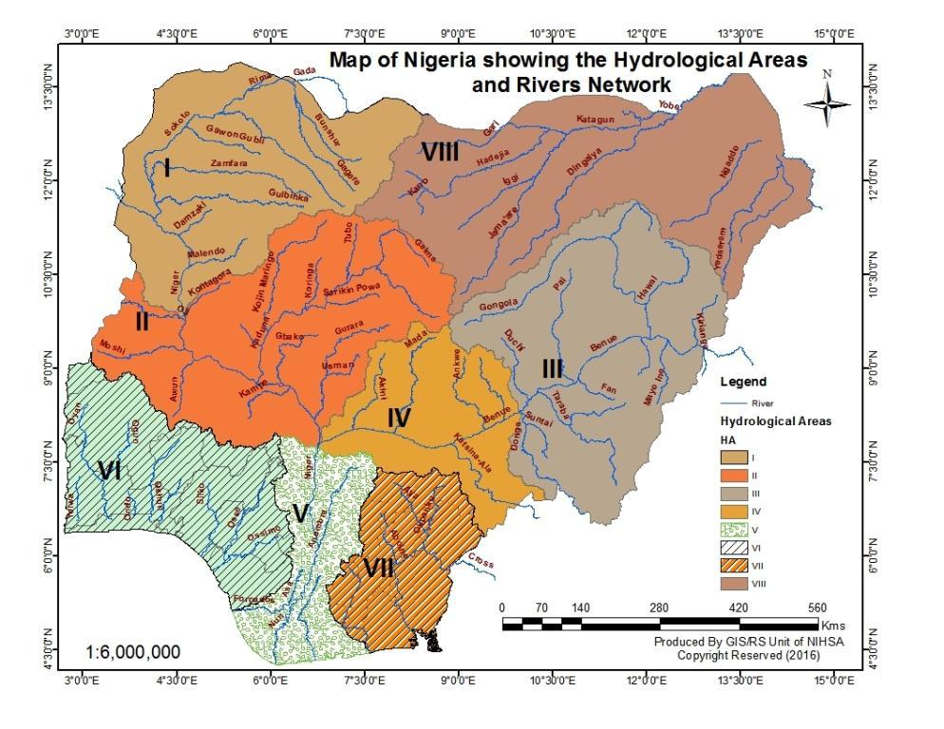
Figure 1: Hydrological Areas and Rivers Network
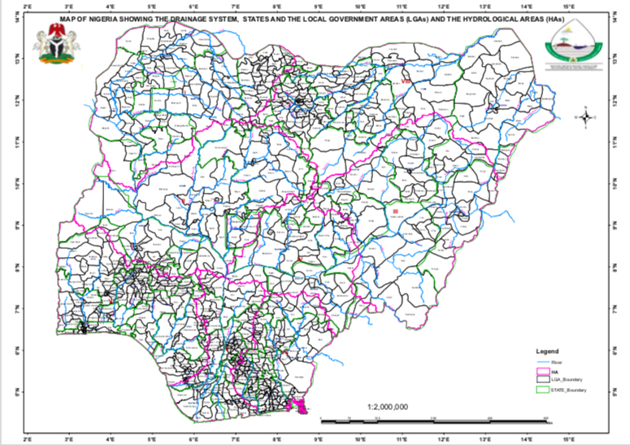
Figure 2.0: Drainage Systems, States and LGAs, and the Hydrological Areas

1.2.2 Changes in Climate Pattern over Nigeria
Systematic weather observation and collection of meteorological data started in Nigeria in 1892 by the then British Colonial Administration in West Africa. The then Department of Meteorological Services continued to collect, process and archive meteorological data all over Nigeria. This function has been inherited, sustained, expanded and modernized by the Nigerian Meteorological Agency (NiMet) since 2003 when the Agency was created by an Act of the National Assembly as a successor to the then Meteorological Department.
Considering the un-uniform nature of the wet season across Nigeria, where the South witnesses predominantly bi-modal wet season and the North predominantly unimodal wet season, it is expedient to repeat the analysis with the 47 meteorological stations sorted into North and South.

figure 2.0 shows that the first decade was consistently dry in the North, a result that reflects the drought experiences of late 70s and early 80s. Within the last three decades (1991-2020), only 1992, 1995, 2000 and 2011 (4 years) were dry years, the majority were wet years, an affirmation of the rainfall recovery over the Sahel region. The last seven (9) years have been consistently wet with the wettest years occurring in the last three years including 2020 which remains second wettest behind 2019 since 1981. Like that of the analysis over the entire country, the general trend has been an increase of 8.7% per annum.

1.2.3 Changes in Onset Dates of Rainy Season
Analyses of climatic data collected over several decades reveal that since 1970 most parts of Nigeria have experienced significant shifts in weather patterns. This statement is supported by the results of analysis of long-term variabilities of temperature, rainfall, hailstorm occurrence in Nigeria.
During the middle of the 20th Century (1941 – 1970), most parts of Nigeria had normal or above normal onset dates of rainy season (using 1911 – 1941 as the base year) except in the areas around Sokoto, Maiduguri, and Calabar (Figure 3a) where the rains came late. As the century progressed (1971-2020) the late onset had spread to more areas leaving only a narrow band in the middle belt and southwest region (Figure 3b) where normal conditions prevailed.

1.2.4 Changes in Cessation Dates of Rainy Season between 1911 and 2000
Analyses of the same data show that by the middle of the century (1941-1970, virtually the entire country had normal cessation of rainy season, in except some parts of southwest which had early cessation (Figure 4a). However, later in the century (1971-2000), most parts of the country began to witness early cessation (Figure 4b). The effect of the late onset and early cessation is that the length of the rainy season became shorter than normal. This pattern still persists in most northern parts of Nigeria and has affected farming practices. As part of adaptation strategies suitable crop species will be needed for shorter length of rainy and crop seasons.
In addition to changes in the onset and cessation dates, it has also been observed that in recent years, rainfall amount has decreased by 15 to 20% while rainfall intensity has increased by about 10 to 15%, on the average. This has led to high surface run-off and more frequent flooding as well as soil erosion in various parts of the Country. The changes in the rainfall pattern have also resulted to the following conditions: shorter lengths of rainy season, shorter cropping season, and may have contributed to the southward spread of aridity in northern parts of the country.

1.2.6 Population and Demography
Nigeria is Africa’s most populous country. It has an estimated population of over two hundred million (200,000,000) people. It is divided into 36 states, the Federal Capital Territory (FCT) and 774 Local Government Areas (LGAs). Nigeria has over 250 ethnic groups, with English as the official language and three major indigenous languages (Hausa, Yoruba and Igbo).
About 70% of Nigeria’s population engages in agriculture.

1.3 Planning Assumptions
In making this Plan, the following assumptions have been made:
- Flood incidents are managed at the local level; and when overwhelmed, assisted by the State Authorities and then by the Federal Government.
- A serious flood disaster results in a large number of casualties and damage to infrastructure, severely affects population and livelihoods; gives rise to the potential threat of disease outbreak; and displaces large numbers of people, triggering the declaration of a national disaster in the affected areas.
- Flood disasters can be caused by nature-induced and human-induced hazards or a combination of both;
- The capacity to respond to heavy flooding and the availability of resources at State, Local and community levels may become easily overwhelmed; and may therefore be unable to perform their duties.
- All Government agencies, critical facility managers and the private sector would have developed flood emergency and contingency plans. These organizations will implement preparedness, mitigation, response and recovery activities and conduct exercises in order to maintain the overall national flood response capability.
- There shall be regular reviews and updates of the Plan through mock drills, simulation exercises and periodic stakeholder meetings to address the emerging needs.
- This plan will be implemented in combination with other relevant Plans such as the National Disaster Response Plan (NDRP), National Contingency Plan (NCP), National Disaster Management Framework (NDMF), Search and Rescue and Epidemic Evacuation Plan (SAREEP) etc.

1.4 Limitation of the Existing Plans
Currently in Nigeria, there exist a number of Disaster Management and related plans. However, most of these plans are either of general nature or limited to other specific emergencies. Moreover, the few plans related to flood preparedness, mitigation and response are quite limited in scope and application, as they focus on agency-specific mandates. Hence, the need to develop comprehensive National Flood Management Plan for the country.

1.5 Flooding Experienced from 2012 - 2018
Nigeria, like many other countries has been experiencing flooding from time immemorial with various degrees of impact and consequences.
In 2012, the great flood incident serves as a base-line year for the National Emergency Management Agency in gathering, collating and analysing data on the impact of flooding in Nigeria. The devastation of the 2012 flood in Nigeria was enormous. According to Nigeria Post Disaster Needs Assessment (PDNA) of 2012, 363 people were killed, 5,851 people were injured, 3,891,314 people were affected, and 3,871,53 people were displaced due to the resulting floods.
In between 2012 and 2018, the Country experienced its fair share of flood incidences. However, 2018 stands out as another year of serious flooding in Nigeria. The impacts of the damages can almost be compared to that of 2012. According to NEMA, the 2018 flooding affected 2,211,871 people, displaced 384,698 people and damaged 128,228 houses.
However, with improved yearly preparedness, mitigation and response efforts, NEMA and all other stakeholders were able to greatly minimize the impacts and effects of floods in the years that followed. Early preparation, proper funding, cooperation, collaboration and coordination are key factors in effective flood (and other disasters) management.

1.6 Impact of Flooding on Development
The colossal losses of economic investments arising from infrastructural damages and means of livelihood usually experienced annually from flood incidences seriously affect Nigeria’s quest for development. Records abound about the yearly destruction of roads, bridges, schools, hospitals, telecommunication infrastructure, houses, business premises and so on.
It takes a lot of financial and other pains-taking investment to restore these public and private assets. For instance, in 2012 alone, the PDNA recorded the total value of physical and durable assets destroyed by the 2012 floods in the most affected states of Nigeria to be around N1.48 trillion (Nigerian Naira), or the equivalent of US$9.5 billion, while the total value of losses across all sectors of the economy was estimated at N1.1 trillion, equivalent to US$7.3 billion. The combined value of these damages and losses was N2.6 trillion, or US$16.9 billion. The overall impact of the flood on real GDP growth in 2012 was estimated at 1.4 percent (N570 billion, in nominal terms).

CHAPTER TWO

2.0 FLOOD RISK MANAGEMENT IN NIGERIA

2.1 Flood Risk
Due to its geography and hydrology, Nigeria is vulnerable to a variety of flood events including coastal flooding from the sea, fluvial flooding from rivers and watercourses, surface water flooding, urban flash and dam failure. Flooding can vary greatly in the hazard it poses, depending on the way that flooding occurs , the speed at which it occurs, the velocity and depth of flow, and the type of flooding. These factors coupled with the specific circumstance of any geographical location will determine its level of risk. This explains the serious perennial flooding in states like Kogi, Kebbi, Bayelsa, Rivers, Delta, Cross Rivers among others.

Types or Sources of Flooding
a. River/Fluvial Flooding: The principal source of river flooding is excessive rainfall within a limited period, which overwhelms the drainage capacity of the land or drainage systems, particularly when the ground is already saturated or when drainage channels become blocked. Weather patterns determine the amount and location of rainfall. Unfortunately, the amount and time over which precipitation (rainfall) occurs is not consistent for any given year or area.
b. Rapid (Flash) Flooding can occur when extensive saturation of high ground accompanied by intense short-duration rainfall in a small catchment or in a heavily built-up area results in sudden release of large volumes of water along narrow channels from high ground to low lying locations.
c. Coastal Flooding: Inundation by the sea on coastal areas is potentially caused by unusually high tide, storm surge, and wave activity including tsunamis. Long-term processes like rising sea level as a result of global warming can lead to encroachment of the sea on land.
d. Groundwater Flooding: Occurs when water levels in the ground rise above surface levels. It is most likely to occur in areas underlain by permeable rocks called aquifers. These can be extensive, regional aquifers such as chalk or sandstone or may be more local sand or river gravels in valley bottoms underlain by less permeable rocks.
e. Sewer F looding: occurs when sewers are overwhelmed by heavy rainfall or when they become blocked. The likelihood of flooding depends on the capacity of the local sewerage system. Land and property can be flooded with water contaminated with raw sewage as a result. Rivers can also become polluted by sewer outflows.
d. Reservoir /Dam Flooding: Some dams/reservoirs hold large volumes of water above ground level, contained by walls or “dams”. Although the safety record for reservoirs is excellent, it is still possible that a dam could fail. This would result in a large volume of water being released very quickly. Therefore this Plan advocates for a FGN requirement that host LGA’s with dams to prepare a Generic Offsite Plan and supporting maps for Reservoir Emergencies.
Such emergencies may result from breach of any reservoir within its boundaries or be related to reservoir inundation from a reservoir outside its boundaries but resulting in flooding. There should be a listing of dams/ reservoirs in Nigeria that hold more than 20,000 cubic meters of water which require an onsite “Site Specific” Emergency Plan. The Plan details the response framework for all sources of flooding – including dam/reservoir inundation.
Experience has shown that 2012 and 2018 floods were caused by opening of Lagdo Dam in Garwa Cameroun Republic due to excess rainfall over there which then flooded River Benue (that has been silted with sand). This river comes into the Country through Adamawa state down to Taraba then Benue and Kogi meeting with River Niger at Lokoja.
NIHSA holds copies of all supporting maps and has shared them with multi agency partners who can ensure a planned response to flooding caused by reservoir inundation.
e. Burst water mains can lead to the rapid flooding of local roads and surrounding properties. In this instance, relevant Water Supply Companies are responsible for their supply up to and including the water stopcock, as well as managing any incident of flood related to bursts.

2.1.2 Causes of Flooding
In Nigeria, the major contributing factors to flooding impacts include:
- Building developments in floodplains
- Lack of drainage systems in cities and poor maintenance of existing ones
- Poor solid waste management
- Poor channelization of rivers and river siltation
- Poor maintenance and utilization of dams
- Poor land use and management practices that increase blockages of hydraulic structures and cause gully erosions
- Trans-boundary flow of water from one near-by river basin into another (e.g. rivers Niger and Benue) and therefore do not respect borders.
- Lack or poor drainage facilities in minor and major roads

Contractor compliance to EIA be enforced by relevant agencies in all construction.

2.2 Effects of Flooding on Nigeria
The consequences of flooding vary with type and nature of the flood. Urban flooding due to heavy rainfall and poor drainage system in a densely populated built up area is an extreme risk which may lead to loss of lives and property, displacement of people, loss of livelihoods and food insecurity among others. A similar event affecting agricultural land is unlikely to cause a serious threat to life but may adversely impact economic resilience of a community. Further, significant flooding affecting a wide area can have substantial economic and public health impacts on communities and infrastructure.

2.3 Flood Context in Nigeria from 2012 – 2020: Impacts and Analysis
In principle, flooding is a natural phenomenon that affects all river basins around the world in more or less regular intervals and that fulfils essential functions in the natural ecosystem. However, owing to human settlements that are being established within floodplains and common development practices which do not leave room for river flow under flood conditions, flooding is mostly considered for its negative rather than its positive effects. Flood is one of the worst natural disasters that not only make the victims homeless and financially disabled, but also cause mental stress, water borne diseases and shattered lives.

In Nigeria, flood disasters and its occurrence have increased rapidly over the recent decades, despite substantial investments by the government in flood prevention, control and management. Flood in Nigeria has caused loss of property, lives and compromised health and sanitation of many communities. The flood recorded in year 2012 was unprecedented and the most devastating to Nigerian people and her economy.
Impacts of Flood:
i. Flood has become a major hazard in Nigeria in recent years due to a growing population, rapid urbanization and extreme weather events, lack of proper spatial planning, poor land use, increased rainfall anomalies, and uncoordinated reservoir operations.
ii. The most notable flood disasters in recent times are 2012 and 2018 floods in which many lives were lost, property damaged and there were general disruptions of livelihoods with attendant adverse socio-economic consequences.
iii. The 2012 flood affected about twenty-seven States of the Federation, causing the deaths of over four hundred persons and displaced about two million people from their homes. The total amount of losses was estimated to be N2.29 trillion in damaged properties, oil production, agricultural and other losses. The overall impact on real GDP growth in 2012 was estimated at 1.4% (NGN570 billion).
iv. In 2018, the devastating flood prompted the Government to declare a State of National Disaster in 12 States of the Federation, including: Adamawa, Benue, Taraba, Kogi, Edo, Kebbi, Kwara, Niger, Rivers, Bayelsa, Anambra and Delta.
v. Nigeria experienced one of the most devastating floods in the year 2020. 34 States and the FCT were ravaged by flood while 320 out of 774 LGAs were affected.

2.4 Rainfall Analysis as Evidence of Occurrence of Extreme Climatic Events in Nigeria
In this section, cumulative rainfall departures from normal (1981-2010), number of rain-days, departures in number of rain-days, analysis of rainfall as recorded in August are discussed.

2.4.1 Cumulative Annual Rainfall: Analysis of the cumulative annual rainfall as recorded in 2020, showed a progressive increase in the annual rainfall amount from north towards the south. Nguru in Yobe state recorded the least amount of 766mm while the highest amount recorded was in Awka in Anambra state 2,707mm. Figure 5 below shows the cumulative amount of rainfall recorded in each state.

Figure 5: Cumulative Annual Rainfall Over Nigeria in 2020

2.4.2 Departures of Cumulative Annual Rainfall in 2020
While majority of the states in the country showed positive departures (above normal) rainfall (areas coloured in different shades of green), normal rainfall was recorded in Kano, Niger, Adamawa, Kogi, Ekiti, parts of Oyo and Cross River states. Negative departures (below normal) rainfall were however recorded in most of the coastal states of Edo, Delta, Akwa-Ibom, Bayelsa, Rivers, Oyo state in the southwest and FCT due to the prolong little dry season (Figure 6).

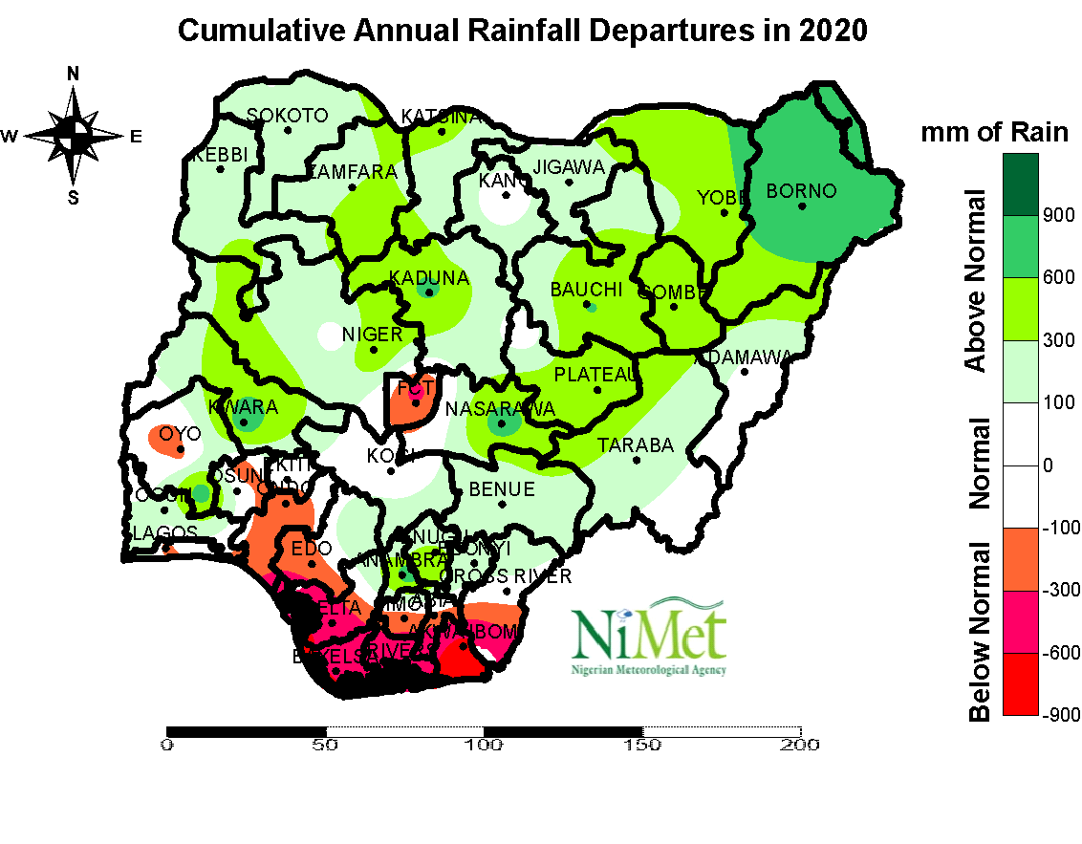

Figure 6: Cumulative Annual Rainfall Departure in 2020

2.4.3 Standardized Rainfall Anomaly
The standardized rainfall anomaly over Nigeria in 2020 shows that the Northern States of the country recorded above normal rainfall except the Federal Capital Territory, parts of Plateau and Yobe that recorded below normal rainfall. While the Southern States of Nigeria like Oyo, Ondo, Edo, Ekiti, Delta, Imo, Bayelsa, Rivers, Abia, Cross River and Akwa Ibom recorded below normal rainfall as compared to the 30 years average. However, parts of Osun, Ogun, Oyo, Enugu, Anambra and Ebonyi recorded above normal rainfall (see Figure 7).

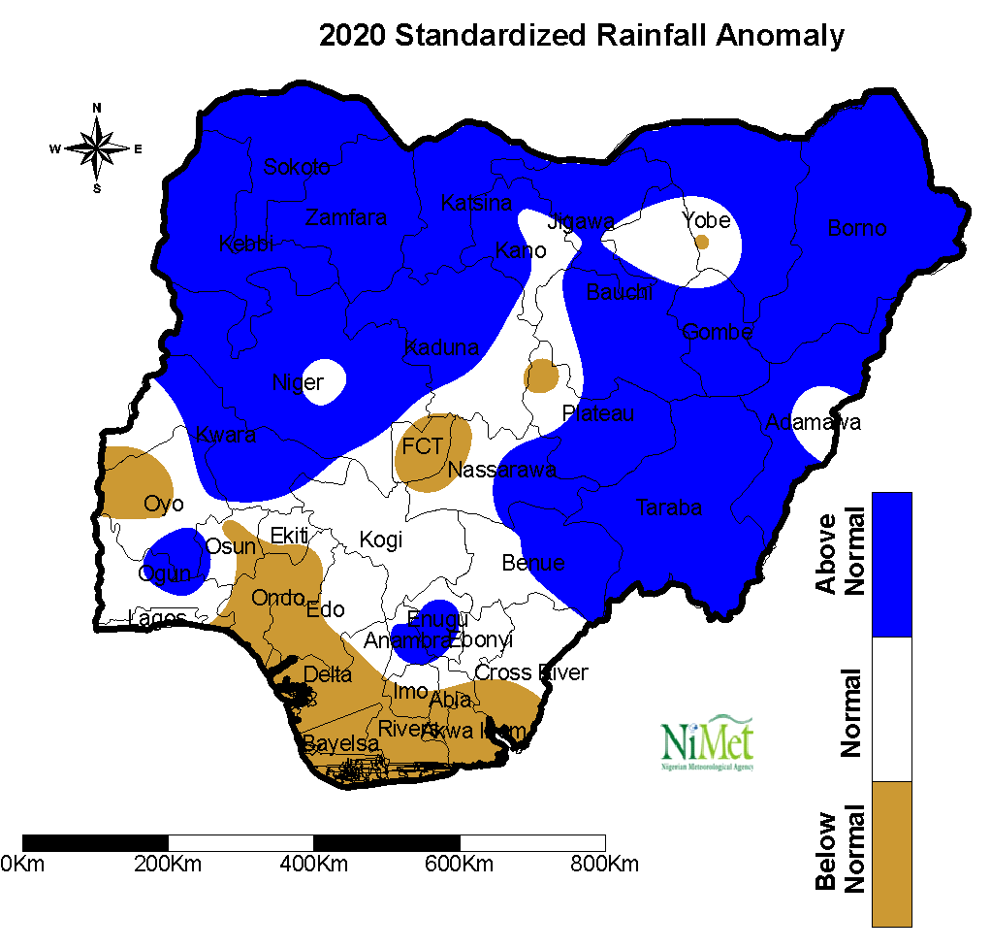

Figure 7: Standardized Rainfall Anomaly Over Nigeria in 2020
2.4.4 Long-term Rainfall Anomaly Trend: Rainfall as very important climate parameter is very essential in many socio-economic lives of any nation. Rainfall amount can pose threats in terms of volume leading to varying degree of flooding when in excess or drought and dry spells when in deficit resulting in losses some of which are irreparable. However, other accompanying events during rainfall such as hailstones, gusty winds etc. are potentially dangerous as well. For the purpose of this report, only the rainfall amount measured by rain gauges across NiMet meteorological Stations have been considered.

Figure 8 presents the magnitude of standardised anomalies of rainfall amount over Nigeria using 47 meteorological stations. While the year under review is a wet year with a standardised anomaly of 1.0 mm, 2019 remain the most significant wet year during the period considered. Aside 2001, the twenty-first century have been consistently wet while the first seven years of the first decade of this analysis is characterised by consistently dry years. The fourteen years between 1998 and 2001 were alternating dry and wet years. The general trend shows an increment of 8.2% per annum.

Figure 8: Standardized rainfall anomalies and trend over Nigeria during the period 1981-2020 based on 47 Meteorological stations and 1981-2010 Climatological average and standard deviation; (green bars represent wet years while brown bars represent dry years)
2.4.5 Standardized August Rainfall Anomaly: The 2020 analysis of the August rainfall shows the Northern states of Borno, Bauchi, Benue, Zamfara, Nasarawa, Kebbi, Katsina, Kaduna, Plateau, Sokoto, and Taraba recorded above normal rainfall (Figure 9). However, Niger, Kogi, Adamawa, Benue, Kwara States and the FCT recorded below normal rainfall. The standardized anomaly shows below normal rainfall was also recorded in all the states of the southern part of the country. This can be attributed to the major dry spell recorded in the month of August in the area.

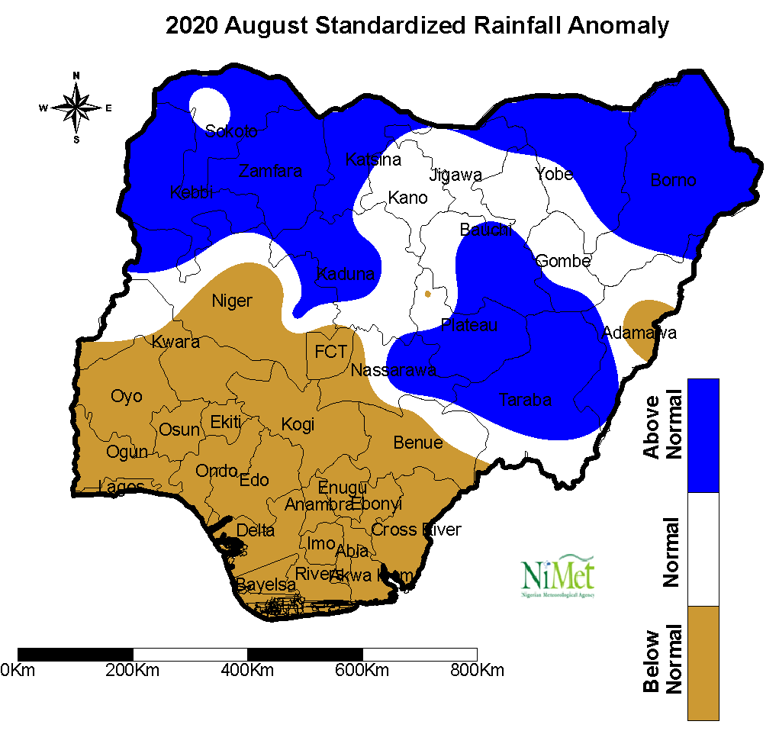
Figure 9: Standardized August Rainfall Anomaly

2.5 Mitigation of Floods
As flood is partly caused by natural hazards such as heavy rainfall, it is obvious that humans cannot completely prevent it. However, with deliberate careful planning, the devastating impacts of flood can be greatly reduced and minimized. As shown in Table 1 below, this requires taking certain measures and actions as well as putting in place specific policies that will build the resilience of the populace.

Some of the measures to be taken including structural and non-structural measures are as follows:
- Structural
- Levee/Floodwall Protection for Multiple Structures
- Levee/Wall for a Single Structure
- Storm Water Detention Facilities
- Storm Water Drainage/Conveyance/Control System
- Evacuations routes
- Multipurpose dams
- Raising facility onto platform (wood, metal, concrete)
- Construction of standard bridges and culverts
- Dredging of silted rivers
- Construction buffer dams

- Non-Structural
- Delineation of Flood prone areas and enforce the building codes
- Automated Flood Notifications
- Public Education
- Flood Insurance
- Audible Flood Warning System for Individual Property
- Involuntary resettlement
- Land use regulations
- Emergency preparedness, response and recovery plans
Table 1. Flood Mitigation Actions/Measures
ACTORS | RESPONSIBILITY
Households | - Households must ensure that they comply with land use planning and zoning regulations of their local municipalities in order to prevent development of residential and commercial properties in high risk flood prone areas;  - Homeowners and renters need to educate themselves before moving into a new home to determine if their home is in a floodplain area. Such information is accessible from LGAs or NIHSA website;  - Be aware of the nearest available escape (evacuation) route in case of emergency  - Construct buildings above flood level  - Install foundation vents or a sump pump  - Use of sand bags  - Device and maintain an internal flood warning system
Communities | - Communities must ensure that their drainage systems are intact by preventing waste disposal in drainages and regularly desilting;  - In the event that a household gets affected by flood, other community members should evacuate the area until authorities say it is safe to return;  - Ensure that buildings are not erected on water ways, drainages etc;  - Identify the nearest available escape (evacuation) route in case of emergency  - Carryout sensitization and advocacy programmes to reach every community person  - Enforce and encourage flood insurance policy for every household
LGAs | - Local authorities must be compelled to review their building laws and codes. Responsible town and community planning can be one of the most powerful tools to minimize flood risks. Communities should go beyond traditional standards and use institutional codes and regulations (localized to their terrain and topography) in building new houses and remodelling existing ones. It will also prepare properties for flood insurance premiums.  - Local authorities should collect, analyse, manage and use relevant data and practical information and ensure its dissemination, taking into account the needs of different categories of users as appropriate;  - Enhance collaboration among people at the local level to disseminate flood risk information through the involvement of community-based organizations and non-governmental organizations;  - Local governments must focus on projects aimed at improving rainwater management or reducing flood risk from a major river. These projects include traditional and innovative practices and can consist of levees, floodwater channels, embankments/floodwalls, land restorations, acquisition of flood-prone properties, rainwater harvest and reuse, etc.
State Governments | - State authorities must ensure that relevant building codes and laws are up to date;  - Periodically assess flood risk, vulnerability, capacity, exposure, hazard characteristics and their possible sequential effects at the relevant social and spatial scale on ecosystems, in line with national circumstances;  - Provide real time access to reliable data, make use of in-situ information, including geographic information systems (GIS), and use information and communications technology innovations to enhance measurement tools and the collection, analysis and dissemination of data;  - State governments should also focus on projects aimed at improving rainwater management or reducing flood risk from a major river. These projects include traditional and innovative practices and can consist of levees, floodwater channels, embankments/floodwalls, land restorations, acquisition of flood-prone properties, rainwater harvest and reuse, flood plain and overflow areas for rivers etc.;  - Build the knowledge of government officials at all levels, local municipalities, civil society, communities and volunteers, as well as the private sector, through sharing experiences, lessons learned, good practices and training and education on flood risk reduction, including the use of existing training and education mechanisms and peer learning
Federal Government | - Enhance access to and support for innovation and technology, as well as in long-term, multi-hazard and solution-driven research and development in the field of flood risk management;  - Systematically evaluate, record, share and publicly account for disaster losses and understand the economic, social, health, education, environmental and cultural heritage impacts, as appropriate, in the context of flood hazard-exposure and vulnerability information;  - Develop and strengthen, as appropriate, mechanisms to follow up, periodically assess and publicly report on progress on national and local plans; and promote public scrutiny and encourage institutional debates, including by parliamentarians and other relevant officials, on progress reports and national plans for flood risk reduction;  - Establish and strengthen government coordination forums composed of relevant stakeholders at the national and local levels, such as national, local and digital platforms for flood risk reduction;  - Allocate the necessary resources, including finance and logistics, as appropriate, at all levels of administration for the development and implementation of flood risk reduction strategies, policies, plans, laws and regulations in all relevant sectors
Legislators | State and Federal Legislators to make laws that would facilitate implementation.

2.6 Preparedness for Floods
Flood preparedness involves actions that must be put in place prior to flooding in order to avoid or minimize the devastating impact of flood disasters by increasing the readiness of communities and institutions to predict, and where possible, prevent flooding, reduce its impact as well as respond to and cope with the consequences. The goal here is to strengthen the capacity of governments, organizations, institutions and communities to avoid confusion and prevent injuries and property damage in the event of a flood disaster. Table 2 outlines some of the preparedness measures to be taken by various actors.
Table 2. Flood Preparedness Actions
ACTORS | RESPONSIBILITY
Households | - Households should insure their homes against flood  - Vulnerable people whose property lies within communities that are within the high-risk flood areas mapped by the appropriate agencies should purchase flood insurance policies  - Make individual household evacuation plans  - Remove important and vital possessions (e.g. documents, perishable items) for safekeeping elsewhere  - Keep abreast and well informed about flood warnings  - Make inventory of household furniture with video and pictorial evidences to help your claim with your insurer  - Elevate and anchor utilities  - Clear debris from gutters  - Elevate or move your furniture  - Have a knowledge of first aid so as to adopt it where necessary
Communities | - Collaborate with local and state authorities in the development of emergency preparedness plans to ensure that their specific needs are captured in the plans  - Set up local voluntary flood responder groups  - Schedule regular group meeting  - Identify community members with special needs  - Participate in emergency drills and exercises to prepare themselves in the event of an actual flood occurrence  - Collaborate with local and state authorities in flood risk management at the local level  - Identify safe grounds for possible evacuation  - Implement an emergency notification system  - Establish and communicate evacuation procedure
LGAs | - Emergency preparedness plans should be tailored to address the specific needs of local communities so the communities must be involved in the development of the plans. The plans should be reviewed every five (5) years  - Set up local voluntary flood responder groups  - Facilitate the conduct of emergency drills and exercises to identify deficiencies in the subsisting plans. In the plans, the communities must be engaged to provide mutual benefits and sharing and/or swapping of critical resources. Practice makes perfect;  - For ease of coordination of efforts, inventory of all infrastructure and equipment for search and rescue held both by the public and private sectors should be updated throughout the year;  - Review existing response plan as part of the preparedness plan. Thus, they must be critical to ask and find answers to questions like “inthe case of flooding”? How would they typically provide water pumps, lay sandbags and clay for temporary levees, ensure that there is the provision of food, drinking water, medicine and other basic tools/implements for communities?  - Since there is no amount of response can equate the losses victims of disaster suffer and since flood is annual, vulnerable persons in vulnerable areas should be encouraged to purchase flood insurance policies. The insurance can be purchased by those whose property lies within communities that are within the high-risk flood areas mapped by the appropriate agencies;  - Work and coordinate with civil society, communities and indigenous peoples and migrants in flood risk management at the local level;  - Promote mechanisms for flood risk transfer and insurance, risk-sharing and retention and financial protection, as appropriate, for both public and private investment in order to reduce financial impact of flood disasters on governments and societies, in urban and rural areas;  - Ensure their Emergency Operations Centres (EOCs) are ready for any emergencies
State Governments | - Ensure that emergency preparedness plans are reviewed every five (5) years;  - Local Emergency Warning Systems (LEWS) must be set up and operational. These systems will ensure that information is available for accurate prediction of flooding conditions. Having information about the flood publicly and readily available can be used to help communities;  - Annually maintain drainages and clear water channels/culverts that will allow free flow of water. Such regular maintenance will go a long way in the adequate preparation for the perennial flooding seasons;  - For ease of coordination of efforts, inventory of all infrastructure and equipment for search and rescue held both by the public and private sectors should be updated throughout the year;  - Ensure that they stockpile food and non-food items and support communities in reviewing their existing response plan as part of the preparedness plan. That is, ensuring that in the event of flooding, the state government is well-equipped to provide water pumps, lay sandbags and clay for temporary levees, ensure that there is the provision of food, drinking water, medicine and other basic tools/implements;  - Adopt and implement local flood risk reduction strategies and plans, across different timescales, with targets, indicators and time frames, aimed at preventing the creation of risk, the reduction of existing risk and the strengthening of economic, social, health and environmental resilience;  - Carryout an assessment of the technical, financial and administrative flood risk management capacity of LGAs to deal with the identified risks at the local level;  - Establish and implement necessary mechanisms and incentives to ensure high levels of compliance with the existing safety-enhancing provisions of laws and regulations, including those addressing land use and urban planning, building codes, environmental and resource management and health and safety standards, and update them, where needed, to ensure an adequate focus on flood risk management;  - Develop and strengthen, as appropriate, mechanisms to follow up, periodically assess and publicly report on progress on local plans for flood risk reduction;  - Encourage good building practices, ensure compliance with building codes , land use, and encourage Build Back Better  - Assign as appropriate, clear roles and tasks to community representatives within flood risk management institutions and processes and decision-making through relevant frameworks, and undertake comprehensive public and community consultations during the development of such laws and regulations to support their implementation;  - Promote mutual learning and exchange of good practices and information through, inter-alia, voluntary and self-initiated peer reviews among interested States;  - Promote the flood risk resilience of at-risk public places;  - Enhance the resilience of health systems, including by developing the capacity of health workers in understanding flood risk and promoting and enhancing training capacities on flood response strategies  - Ensure that all the Emergency Communications Centres (ECC) across the country are hitch-free and well-equipped to handle traffic;  - Provide special care for vulnerable groups including women, children, people with disabilities, and those with life-threatening and chronic disease to manage their risks before, during and after flooding.
Federal Government | - Enhance the resilience of national health systems, including by integrating disaster risk management into primary, secondary, and tertiary healthcare, especially at the local level;  - Develop the capacity of responders, especially health workers, in understanding disaster risk and applying and implementing disaster risk reduction approaches in health work; promoting and enhancing the training capacities in the field of disaster medicine; and supporting and training community health groups in disaster risk reduction approaches in health programmes, in collaboration with other sectors, as well as in the implementation of the International Health Regulations (2005) of the World Health Organization  - Carryout annual flood sensitization campaigns well before the onset of rains  - Encourage good building practices, ensure compliance with building codes, land use, and encourage Build Back Better
Legislators | State and Federal Legislators to make laws that would facilitate implementation.

2.7 Response to Flood
Response is initiated when flooding is imminent. Generally, this will occur when river stage (water height) is expected to reach or exceed stream channel capacity resulting in water threatening or impacting people, property, or infrastructure. Activities required here are those that minimize casualties and damage to properties. Various activities to be taken by responders at all levels are outlined in Table 3.
Table 3 Flood Response Actions
ACTORS | RESPONSIBILITY
Households | - Individuals must immediately vacate the flooded area in the event that flooding starts. Returning for personal possessions will stall recue and increase casualties  - Turn off all utilities at the main power switch  Join neighbours and volunteers to put sandbags away from the outside walls of houses to prevent flood waters from entering  Listen to radio for evacuation instructions  Follow recommended evacuation routes
Communities | - Communities must comply with flood response instructions;  - In the event that a household gets affected by flood, other community members should evacuate (i.e. encourage the use of first responders) the area until authorities say it is safe to return;  - Help authorities identify vulnerable people such as the elderly, children, people with disabilities, and those with life-threatening and chronic disease, due to their particular needs, and to extend support if need be.
LGAs | - Local authorities are crucial in this phase, therefore, are required to provide immediate assistance such as organizing, facilitating, and conducting search and rescue, evacuating victims to higher grounds, providing relief materials and any other action(s) that will save lives and properties. The earlier they reach the victims or flood site, the more the chances of having successful rescue;  - People with disabilities or life-threatening and chronic iseases, due to their particular needs should be provided with extra support, as appropriate, to manage their risk during and after flooding disasters.
State Governments | - State authorities must support local municipalities in the provision of immediate assistance such as organising, facilitating, and conducting search and rescue, evacuating victims to higher grounds, providing relief materials and any other action(s) that will save lives and properties. They must recognize that the primary goal here is to meet people’s basic needs until recovery begins;  - Activate the Emergency Operations Centres (EOC) and maintain state of readiness with all equipment in working order to ensure effective response  - Set up internally displaced persons camps in identified high grounds to cater for vulnerable persons
Federal Government | - Ensure that the ECC both at the national and state level are activated commensurate to the level of response required
Legislation | State and Federal Legislators to make laws that would facilitate implementation.

2.8 Recovery from Floods
This is initiated when the threat of flooding is over. The actions in this phase must be those that bridge the gap between the emergency situation and return to normalcy. Therefore, in the aftermath of a flood disaster, all relevant actors must take up their responsibilities as shown in table 4 below, to enable victims to return to their normal lives prior to the flood.
Table 4. Flood Recovery Actions
ACTORS | RESPONSIBILITY
Households | - Households should activate their insurance cover  - Seek professional advice on cleaning homes after flood as flood waters carry with it some dangerous chemicals to ensure that victims homes are safe to habitat again  - Seek for help where necessary by calling your insurance agent and other forms of help that you may require
Communities | - Support each other to rebuild their communities  - Provide emotional support to each other  - Seek development projects that can protect homes from flooding
LGAs | - Support the reconstruction of damaged basic public infrastructure  - Assist people and businesses to return to their normal lives
State Governments | - State governments should conduct rapid damage and loss assessment to ascertain the magnitude of damage caused by flooding  - Support the replacement and restoration of damaged basic public infrastructure;  - Provide financial assistance to support victims;  - Provide psycho-social counselling and education to victims;  - Provide agricultural intervention support to affected farmers and farming communities;  - Generate and maintain a robust data base of flood impacted communities and persons for interventions from the Federal Government, CSOs and NGOs
Federal Government | - Provide agricultural intervention support to affected farmers and farming communities;  - Provide financial assistance to support victims;  - Provide psycho-social counselling and education to victims;  - Support local authorities in the reconstruction of damaged basic public infrastructure
Legislation | State and Federal Legislators to make laws that would facilitate implementation.

The Incident Command Structure to be adopted in responding to flood disaster is as shown in Figure 10 below.

Figure 10: Incident Command Structure for Flood
Source: SAREEP

CHAPTER THREE

FUNDAMENTAL CONSIDERATIONS OF FLOOD FORECASTING AND WARNING SYSTEMS
Floods are without doubt among the most devastating of natural disasters, striking numerous eco-climatic regions in the country each year. During the last decades the trend in flood damages has been growing exponentially. The development of hydrological forecasting and warning systems is therefore an essential element in regional and national strategies. Sustainable economic and social development requires that flood forecasting and warning systems for communities at risk, be continuously developed, which in turn demands an optimal combination of data, forecasting tools and well-trained specialists. A flood forecast and warning system must provide sufficient lead time for communities to respond. It is expected that this chapter will serve as a useful guide for the Country to establish such systems.
To form an effective real-time flood forecasting system, the basic structures need to be linked in an organized manner. This essentially requires:
- Provision of specific forecasts relating to rainfall for both quantity and timing, for which numerical weather-prediction models are necessary;
- Establishment of a network of manual or automatic hydrometric stations, linked to a central control by some form of telemetry;
- Flood forecasting model software, linked to the network of hydro-metrological observing stations and operating in real time.
Flood warnings are distinct from forecasts, as they are issued when an event is occurring, or is imminent. Flood warnings must be issued to a range of users such as farmers, transporters, emergency managers and so on for various purposes. These purposes include:
  - To bring operational teams and emergency personnel to a state of readiness;
  - To warn the public of the timing and location of the event;
  - To warn as to the likely impacts on, for example, roads, dwellings and flood defence structures;
  - To give individuals and organizations time to take preparatory action;
  - In extreme cases, to give warning to prepare for evacuation and emergency procedures.
Early warning of a flood may save lives, livestock and property and will invariably contribute to lessening of the overall impact. Flood warnings need to be understood quickly and clearly and so considerable attention has to be given to how technical information is conveyed to non-specialists from organizations, the public, the media and in some cases illiterate population groups. There are a number of features common to all flood forecasting and warning systems, which are related to causes, impacts and risks. The following main and subsidiary characteristics require full consideration.

3.1 Meteorological Considerations: Meteorological phenomena are the prime natural causes of flooding, either as rainfall or snow and snowmelt. Clearly the ability to forecast critical events, in both time and space and also quantitatively, is of significant value in flood forecasting and warning. Meteorological knowledge associated with flood warning issues fall into two broad areas, namely the climatology behind flooding and the operational meteorology involved. The Nigerian Meteorological Agency (NiMet) would be expected to be the best equipped to provide both, perhaps with the assistance of other appropriate organizations.
Climatology includes the understanding of rain-bearing systems, their seasonality and the extremes of their behaviour. Understanding the types of weather systems from which flooding can originate will contribute largely to decisions about what sort of observational and forecast systems may be required. Thus in a semi-arid zone, where flash floods are predominant, the observation and forecasting facilities must be geared towards rapid recognition of an event. The most effective means for this would be by satellite or radar, while broad scale, synoptic forecasting would be of limited value.
Hydro-meteorological data (primarily rainfall, but also evaporation) are vital to flood forecasting and warning operations and they are usually dealt with separately from climatological data. The purpose of the data and its analysis is to estimate the severity and probability of actual or predicted events and to place them in context. Long-term records are essential and this requires investment to install and maintain rain-gauge networks (plus evaporation and/or climatological stations), to assure staff and facilities to process and analyse records and to maintain a flexible and accessible database.
Hydro-meteorological data are also vitally required in real time for the provision of flood forecasts and warnings. It is important that a representative proportion of the rain-gauge network is linked to the forecasting and warning control centre by telemetry. This has a three-fold aim:
  - To allow staff to monitor the situation in general terms;
  - To give warnings against indicator or trigger levels for rainfall intensity and–or accumulations;
  - To provide inputs into forecast models, particularly for rainfall–runoff models.
3.2 Hydrological Considerations: The requirements concerning hydrological information for a flood forecasting and warning system are similar to those for meteorology, in that it is necessary to have an understanding of the overall flood characteristics of Nigerian Hydrological Basins as well as having real-time information for operational purposes. Key observation and data requirements are for water levels in lakes and rivers, river discharge and in some cases groundwater levels. The observation stations have a dual role in providing data for long-term statistics and through telemetry to provide data to a control centre. Water level ranges at given points can be linked to various extents of flooding, so a series of triggers can be set up to provide warning through telemetry. The upstream-downstream relationship between water levels is an important means of prediction. Early flood warning systems depend on knowledge of the comparative levels from a point upstream to resulting levels at a point of interest at the flood-risk site and the time taken from a peak at an upstream point to reach a lower one. These are usually presented as tables or graphs of level-to-level correlations and time of travel. Developments in real-time flood modelling now provide the facility to provide more comprehensive information on prediction.

3.3 Nature of Risks and Impacts: Risk may be defined as the probability of harmful consequences or expected human injury, environmental damage, loss of life, property and livelihood, resulting from interactions between natural or human hazards and vulnerable conditions. Flood risks are related to hydrological uncertainties, which are inextricably linked to social, economic and political uncertainties. In fact, in characterizing future flood risk, the biggest and most unpredictable changes are expected to result from population growth and economic activity. This can be demonstrated by the historical development of coping with flooding, where the initial resilience of a largely rural population is lost by more complex societies. Flood-risk management consists of systematic actions in a cycle of preparedness, response and recovery and should form a part of Integrated Water Resources Management (IWRM). Risk management calls for the identification, assessment, and minimization of risk, or the elimination of unacceptable risks through appropriate policies and practices.
Flood warning activities are largely designed to deal with certain design limits of flooding, for example within a range of probabilities, and monitoring, modelling and operational systems can be set up in relation to known risks and impacts. In particular, these will focus on areas of population, key communications and infrastructure and the need to operate effective responses to flood. The magnitude of flood events and hence impacts are variable, so flood forecasting and warning has to operate over a range of event magnitudes. These vary from localized, low-impact flooding, which can be countered by relatively simple measures, such as installing temporary defences, closing flood gates and barriers, to larger scale flooding, where property damage and losses occur, road and rail closures arise and evacuation of areas at risk takes place. Defence and remedial measures are designed or planned to operate up to a particular severity of flooding, which may be designated as having a particular probability. The measures are related to an economic decision relating costs against losses. Typical design criteria are 100 years (an event that is considered to have a 1 per cent chance of occurring in any given year) for urban areas with key infrastructure, 50 years (2 per cent) for lesser population centres and transport facilities, 20 years (5 per cent) for rural areas and minor protection structures.
Beyond the limits of designed flood management and particularly for catastrophic events, for example dam or embankment failure, some aspects of flood forecasting and warning provisions may not be fully effective. However, it is important that in these cases monitoring facilities are sufficiently robust, as some continuing observations will be of vital assistance to emergency response and relief activities. In this respect, resilience of monitoring instruments, their structure and telemetry, are of considerable importance, especially as on-the-ground reporting may have become impossible.
3.4 Dissemination of Forecasts and Warnings: The effective dissemination of forecasts and warnings is particularly important. A balance must be struck between information to the public and information to other bodies involved with flood management. Historically, this has resulted in a dichotomy for flood warning services, which must partition support resources between the community and government. The subject has been the focus of severe criticism in the light of past failures at service delivery. Thus, the language used and the type of information passed on has to be carefully considered and structured. There has been a gradual evolution away from confining flood forecasting and warning information to authorities, that is, government, to a more direct involvement of the public. This has been helped by the growth in telecommunications, the computer, the IT revolution and increased ownership and coverage of media, such as radio and television. It is important, however, to maintain a broad spectrum for dissemination and not to be seduced by high-tech approaches. Even in technically advanced societies it is doubtful whether Internet communication of flood warning information can be entirely effective. The elderly and poor members of the community may not have the necessary facilities at home and it may also be doubtful whether people will consult websites when a dangerous situation is in place. It must also be remembered that these systems are dependent on telecommunications and power links that are themselves at risk of failure during flood events.
As a counter to over-sophistication and reliance on high-tech methods some alternative facilities need to be provided. In the past, in most parts of the world, emergency services (police, fire service, civil defense) have been closely involved in flood relief activities. Their role may change with changing technology, but they still need to be involved in communicating flood warnings and rescue. Other general warning systems, such as flood wardens and alarm sirens should not be abandoned without careful consideration of the consequences. Similarly, rudimentary methods of information dissemination (ie the use of town criers) that are indigenous to each community need to be reviewed and enhanced to ensure they are prompt, accessible, effective and easily accepted.
3.5 Institutional Aspects: A flood forecasting and warning system needs to have clearly defined roles and responsibilities. These are wide ranging, covering, inter alia, data collection, formulation and dissemination, uncertainty of outputs and any legal or liability requirements. Whatever the functional and operational responsibilities of the separate agencies involved in flood forecasting and warning, there is a fundamental responsibility through central (federal) government for public safety and emergency management. There may not be, however, a general statutory duty of the government to protect land or property against flooding, but government recognizes the need for action to be taken to safeguard the wider social and economic well-being of the country. Operating authorities may have permissive powers but not a statutory duty to carry out or maintain flood defence works in the public interest. However, such responsibilities may be incorporated through legislation within acts and regulations under which different government departments operate. When legislation is set up or amended, it is therefore extremely important that interfaces between the duties and obligations of affected departments are carefully considered before statutory instruments are introduced.
3.6 Legal Aspects: Any flood forecasting and warning system has to deal with uncertainty. This is inherent due to the nature of the meteorological and hydrological phenomena involved. Similarly, there are uncertainties involved with equipment and human error within any operational structure. Uncertainty may be dealt with in the design and planning processes, where a decision is made on the level of uncertainty, that is, the risk of failure that is acceptable. This then becomes a balance between the costs of safe design against that of the losses caused by damage. Except where “total protection” is provided for key installations such as national security locations and nuclear plants, aspects of uncertainty can be approached through probabilistic methods. The probabilistic approach is increasingly being used as part of risk analysis, where impact and consequence in human and economic terms are linked with the causative meteorological and hydrological characteristics.
Liability in strict legal terms is difficult to apply to the various activities in flood forecasting and warning. Whereas a contractor may face liability for the failure of a flood protection structure (for example a dam or a flood wall) or a manufacturer for a product not meeting specifications as to flood resistance or proofing, most national and international legal systems and codes regard floods and the causes thereof as “Acts of God”. Liability regarding flooding tends to operate in a “reverse” way, that is, that compensation or redress for losses and damage may not be given if a case shows that there has been some form of negligence in design or that guidelines have been ignored. In many countries governments or international agencies can provide compensation or assistance in rebuilding, but there is no legal obligation. Insurance is increasingly fulfilling the role of government in recovery actions, particularly in developed countries where it is a commercial arrangement. Increasing use of insurance has, however, meant that when events occur, the cost to insurance companies becomes larger, leading to rises in premiums. This situation also leads to insurance companies deciding on what is or is not a worthwhile risk, which often leads to properties in high-flood-risk areas being uninsurable
CHAPTER FOUR
INSTITUTIONAL FRAMEWORK
This Plan will involve all stakeholders in the disaster management circle as all of them will have a role to play in the mitigation, preparedness, response, and recovery from flood. The stakeholders in the Plan will have roles and responsibilities in the execution of the plan, thus, each stakeholder will be responsible for the operational and role-based training required to support their duties in the Plan. MDAs are to maintain records of their training programmes. There is value to carrying out joint training and exercising at both the strategic and tactical level. Whilst tactical level training should be coordinated by each individual MDA, strategic and wide-area training and exercise would be organized by FMHADMSD. Some key stakeholders are listed in 4.1 through 4.4.
4.1 Local Governments/Community capacity/capability towards disasters/floods
The Local Government is the third and weakest tier among the three-tier federal arrangement in Nigeria. Some of the local government institutions that can help in flood preparedness, mitigation and response in Nigeria include:
- Local Emergency Management Committees (LEMCs)
- Department of Works
- Department of Agriculture
- Department of Health
- Community Development Associations

4.2 State Governments and their capacity/capability towards disasters/floods
Some State Government institutions that may have responsibility for flood preparedness, mitigation and response include:
- State Emergency Management Agencies (SEMAs) and Federal Capital Territory Authority FCTA (which covers FCT Abuja)
- State Ministry of Environment
- State Ministry of Works and Housing
- State Ministry of Health
- State Ministry of Water Resources
- State Ministry of Agriculture and Rural Development
- State Development Control agencies
- State Ministry of Information
- State Ministry of Education
- Ministry of Lands, Survey and Urban Development
- State Fire Service

4.3 Federal Government MDAs and their capacity/capability towards disasters/floods
At the Federal level, there are several ministries, departments and agencies (MDAs) whose mandates place on them some responsibilities to play key roles in flood management in the wider context of flood preparedness, mitigation and response. Key among these MDAs include:
- Federal Ministry of Humanitarian Affairs, Disaster Management and Social Development (FMHADMSD)
- National Emergency Management Agency (NEMA)
- Nigerian Meteorological Agency (NiMet)
- Nigeria Hydrological Services Agency (NIHSA)
- Federal Ministry of Environment (FMEnv)
- Federal Ministry of Water Resources (FMoWR)
- Federal Ministry of Health (FMoH)
- Federal Ministry of Agriculture and Rural Development
- Federal Ministry of Information and Culture (FMIC)
- Defence Headquarters (DHQ)
- Nigeria Security & Civil Defence Corps (NSCDC)
- Federal Road Safety Corp (FRSC)
- Nigeria Police Force (NPF)
- National Orientation Agency (NOA)
- Federal Fire Service
- National Space Research and Development Agency (NASRDA)

4.4 Other Stakeholders & their Capacity/Capability towards Disasters/Floods
Other relevant stakeholders that can play significant roles in flood preparedness, mitigation and response in Nigeria include:
- Nigerian Red Cross Society (NRCS)
- Government Regulatory agencies (COREN, TOPREC, etc.)
- UN Agencies (UNDP, UNOCHA, UNICEF, WHO, etc.)
- Development Partners (USAID, EU, UKAID, JICA, Swiss Dev Corp etc.)
- INGOs (SCI, AAH, OXFAM, etc.)
- Local NGOs
- Professional Associations (Nigerian Society of Engineers, Nigerian Institute of Town Planners, Nigerian Institute of Architects etc.)
- Local Voluntary Responder Groups Non-Governmental Organizations
- Faith-based Organizations
- Construction Companies

4.5 Flood Coordination Mechanism
Coordinating flood hazards and emergencies in the country requires a multi-stakeholder and multi-sectoral approach given the technical expertise and mandates of respective MDAs as well as the cross-cutting effect and the impact of flooding in the country. Over the years, flood in Nigeria has impacted agricultural activities, destroying crop yields, pricing, and thereby affecting food security as well as environmental security. There are also linkages to the effects of flooding to other sectors including health, education, and the economy.
The objective of this section is to explain the national/centralized coordination architecture for managing flooding hazards and disasters in Nigeria. It presents an essential part of the policy because current operations are fragmented with multiple actors carrying out respective activities and interventions within the scope and coverage of their mandates. For instance, the National Emergency Management Agency (NEMA) role in flooding response involves analysing and advocating to State governments; responding through search and rescue and the provision of emergency relief and livelihood support, as well as facilitating relocation and reconstruction efforts. It is noteworthy that NEMA efforts are conducted in a multisectoral manner and stakeholders MDAs are involved. However, while specific structure works seamlessly at the federal level, they defer at the state level, where SEMA are expected to provide such leadership and coordination at the local level. Another issue raised by the lack of a definite structure is the overstretching experienced by emergency response agencies, specifically NEMA at the federal level due to the limited participation and weak capacity of subnational local stakeholders. This has led to gaps and duplications in flooding interventions especially in situations where interventions fail to trickle down to the grassroots.
The proposed new coordination framework takes into account the Sendai Framework which emphasizes coordination frameworks at the country level and prerequisites “meaningful participation of relevant stakeholders at appropriate levels” in disaster risk reduction. In fact, a guiding principle is that “Disaster risk reduction requires that responsibilities be shared by central Governments and relevant national authorities, sectors and stakeholders, as appropriate to their national circumstances and systems of governance”. Notably, the framework identities activities, and roles and responsibilities for both national and local governments/levels, as well as global and regional institutions.
The proposed coordination mechanism emphasizes leadership, communication, and participation at all levels, with specific emphasis on the subnational and local levels; thereby realizing holistic and people-centric solutions to flooding. The proposed structure prioritizes a bottom up and participatory approach while maintaining the top-down/centralized structure for supervision with the objective of aligning all efforts for greater impact. As such, the hybrid coordination strategy will focus on area-based planning, coordination and programming to enable localization and taps into greater efforts towards the implementation of the humanitarian-development-peace nexus to address hazards and crises throughout the country.
It is on this basis; the proposed flood coordination framework is structured:
At first glance, there are lead and supporting/sub-lead MDAs whose mandates provide policy direction and operational guidance. The structure further creates a high-level committee which focuses on policymaking, political advocacy and engagements and implementation monitoring. The High-Level Committee, led by the Federal Ministry of Humanitarian Affairs, Disaster Management and Social Development comprises of Ministries whose agencies and parastatals have mandates in the disaster management cycle as it pertains to flood. It serves as a centralized body for policy review and implementation.
Meanwhile the operation level, the Technical Committee Level, led by the National Emergency Management Agency and co-led by the State Governor/SEMA Chairpersons/Representative focuses on efforts towards strengthening the capacity and participation of local stakeholders and the provision of services in each of the flooding risk reduction phases (namely prevention and mitigation; preparedness; response; and recovery (resilience) and reconstruction) taking into account the peculiarities of each affected local government area or state. Therefore the scope of its operations of this Committee at the sub-national level and activities will include conducting needs assessment and analysis, and stakeholders’ mapping exercises, designing and implementing measures and strategies (for each phase); and monitoring and evaluating impact. The methodology shall include desk reviews, field visits and engagements, data collection and regular coordination meetings with multi-sectoral stakeholders.
Finally, all stakeholders: which include Federal and State Governments; MDAs; the private sector, NGOs, INGOs and development partners, traditional rulers and religious leaders, dam managers, town planners, academics, and professional institutes, and most importantly, affected persons/population will be categorized within the 4 phases for effective and efficient operational service delivery based on expertise. A feedback mechanism shall be set up to ensure sufficient community participation and follow up.
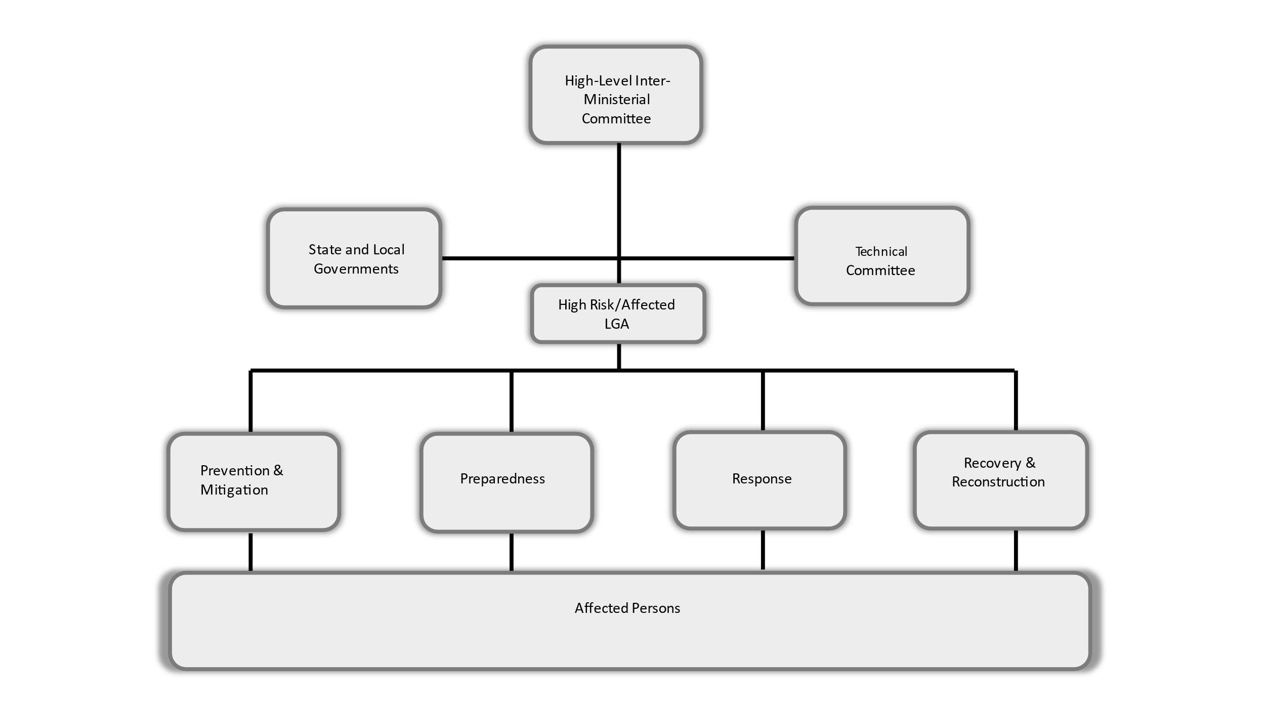
Figure 11: Flooding Coordination Structure/Framework

CHAPTER FIVE

ROLES AND RESPONSIBILITIES OF STAKEHOLDERS IN FLOOD MANAGEMENT IN NIGERIA

5.1 Mitigation: Responsible Stakeholders and Specific Actions to take
The mitigation of flood risks are actions that need to be taken by all relevant stakeholders to limit the impact and consequences of flood on victims and communities. The Table 5 below gives the roles and responsibilities of the actions that must be taken in mitigating flood. It also gives the times that these actions must be taken.
Table 5. Action Plan for Flood Mitigation
S/N | ACTIONS | ACTORS | TIME OF ACTION | REMARK
1 | Prediction | - NiMet  - NIHSA  - FMoEnv  - Relevant Research Institutions  - Relevant Development Partners | First quarter of every year
2 | Dissemination of flood risk information (Early Warning) | - FMHADMSD  - NEMA  - SEMA  - FMC&DE  - FMIC  - NCC  - NTA  - FRCN  - NOA  - NIHSA  - Print Media  - LEMC  - Media  - Relevant Development Partners  - State Min. of Inf.  - State Bureau of Orientation  - NRCS  - NiMet | First quarter of every year
3 | Sensitization of communities | - FMHADMSD  - NEMA  - SEMA  - LEMC  - NIHSA  - FMC&DE  - FMIC  - NTA  - FRCN  - FMoH/SMoH  - Relevant Development Partners  - Nigerian Red Cross Society  - Voluntary Responder Groups  - FMEnv  - LEMC  - NSCDC  - SMEnv  - Traditional Rulers | Quarterly.  1st quarter to sensitize ahead of raining season  2nd Quarter during the raining season when flood is prone to occur  3rd quarter when the rains have subside to share the lesson learnt and evaluate the effect of the sensitization
4 | Review and enforce building laws and codes that mitigate floods | - FMW&H  - SMW&H  - SMWR  - FMEnv  - SMEnv  - NSE  - State Ministry of Urban Planning  - FFS  - National and State Assemblies  - NESREA | Every 10 years
5 | Strengthen efforts of flood risk reduction interventions such as awareness campaigns | - SMWR  - SMEnv  - FMWR  - FMARD  - EFO  - LGAs  - Relevant Development Partners  - NSCDC  - SEMA  - Fire Service  - FMEnv | Annually
6 | Assessment of flood risk, vulnerability, capacity, exposure, hazard characteristics and their possible effects | - FMHADMSD  - NEMA  - SEMA  - NiMet  - NIHSA  - FMEnv  - NESREA  - FMWR  - FMoH  - Relevant Research Institutes  - NRCS  - Relevant Development Partners | 1 – 5 years | M&E of FMHADMSD will coordinate
7 | Training of government officials, local governments, civil society, communities and volunteers, and the private sector on flood risk reduction | - NEMA  - SEMA  - FMHADMSD  - NRCS  - Fire Service  - FMoH  - Relevant Research Institutes  - UNOCHA  - Relevant Development Partners | Yearly
8 | R&D in the field of flood risk management | - FMHADMSD  - NESREA  - NiMet  - NIHSA  - NEMA  - SEMA  - Universities & Research Institutions  - Relevant Development Partners | Annually
9 | Flood Insurance | - NAICOM  - Insurance Companies

5.2 Preparedness: Responsible Stakeholders and Specific Actions to take
The responsibility of preparing for flood is for all stakeholders. Thus, the Preparedness phase of this plan includes stakeholder planning, training, and raising awareness for the imminent flood as must have been predicted. The Table 6 below shows the actions, actors and the times or actions that will lead to a successful execution of the plan.
Table . Action Plan for Flood Preparedness
S/N | ACTIONS | ACTORS | TIME OF ACTION | REMARK
1 | Development of Emergency Preparedness Plans at State level | - SEMA  - Relevant state ministries (i.e. Health, Environment, Water Resources, Humanitarian Affairs etc)  - Relevant CSOs/NGOs  - LEMCs | Every 3 years | NEMA to give technical support
2 | Conduct emergency simulation exercises | - NEMA  - SEMA  - DRUs  - NSCDC  - NPF  - NRCS  - FS  - FRSC  - FMoH  - FMWR  - FMARD | Every 2 years | To be coordinated by FMHADMSD due to inter-ministerial nature
3 | Update of the inventory of infrastructure and equipment for search and rescue (and emergency treatment) | - FMHADMSD  - NEMA  - SEMA  - DHQ/DRUs  - Fire Service  - NSCDC  - FMoH  - Other Relevant Stakeholders | Year round | FMHADMSD leading, to be assisted by NEMA
4 | Review of existing emergency response plans | - NEMA  - FMoH  - FMEnv  - FMWR  - Relevant Federal MDAs  - SEMA  - SMoH  - SMEnv  - SMWR  - Relevant State MDAs  - UN and other Relevant Development Partners | Every 3 Years | FMHADMSD supervising
5 | Provide flood risk transfer and insurance schemes | - NAIC  - FMARD/NAIC  - Relevant State MDAs | Year round | FMHADMSD as coordinating Ministry
6 | Facilitate coordination between government, civil society, communities and indigenous peoples and migrants in flood risk management at the National, State and Local levels | - FMHADMSD  - NEMA  - SEMA  - LEMC  - Relevant UN and other Development Partners | Year round
7 | Identify safe grounds for camping of flood victims | - NEMA  - SEMA  - OSGOF/ State equivalent | First quarter of every year
8 | Dissemination of Flood Early Warnings | - NIHSA  - NiMet  - NEMA  - SEMA  - FMC&DE  - FMIC  - NCC  - NTA  - FRCN  - NOA  - NSCDC  - FMHADMSD  - NIHSA  - Print Media  - LEMC  - Media  - Relevant Development Partners  - State Min. of Inf.  - State Bureau of Orientation  - NRCS  - NiMet  - FMEnv | First quarter of every year
9 | Regular maintenance of drainages and clearing of water channels/culverts | - SEMA  - SMEnv  - LEMCs  - NGOs  - Communities | Year round | FMHADMSD and NEMA supervising
10 | Stockpile food and non-food items | - NEMA  - SEMA  - NAFDAC  - NGOs  - NRCS  - NCFRMI  - FMARD  - Relevant Development Partners | First quarter of every year
11 | Assessment of the technical, financial and administrative flood risk management capacity of LGAs | - NEMA  - SEMA  - LEMC  - Relevant Federal MDAs (ie FMFBNP)  - LG Department of Health  - Relevant Development Partners | First quarter of every year | FMHADMSD to supervise
12 | Establish and implement mechanisms and incentives to ensure compliance to relevant laws and regulations (i.e. building codes, waste and environmental management laws among others) | - FMFBNP  - NESREA  - FMW&H  - FMWR  - NSE  - FMOI  - SON  - FMEnv  - Ministry of Justice  - State Ministry of Urban Planning or its equivalent | Annually | FMHADMSD to supervise
13 | Developing mechanisms to follow up, periodically assess, and publicly report on progress on local plans for flood risk reduction | - LEMC  - SEMA  - SMEnv  - SMoH  - Relevant state ministries  - Relevant Development Partners | Periodically | FMHADMSD and NEMA to provide technical assistance
14 | Assigning clear roles and tasks to community representatives within flood risk management institutions | - SEMA  - LEMC | Periodically | NEMA to supervise
15 | Promoting mutual learning and exchange of good practices | - FMHADMSD  - NEMA  - SEMA  - Relevant State Ministries  - Relevant Development Partners | Periodically | FMHADMSD to supervise
16 | Promoting the flood risk resilience of Communities at risk | - SEMA  - LEMC  - Communities  - NSCDC  - Relevant Development Partners | Periodically | FMHADMSD and NEMA to promote
17 | Developing the capacity of health workers on flood response strategies | - FMoH  - NPHCDA  - NEMA  - SEMA  - NSCDC | Annually | FMoH to coordinate
18 | Provision of special care for vulnerable groups to manage their risks before, during and after flooding | - FMHADMSD  - NEMA  - SEMA  - PWDC  - NCFRMI  - NRCS  - NAPTIP  - UN, ECOWAS and other Relevant Development Partners | Year round | FMHADMSD to coordinate

5.3 Response: Responsible Stakeholders and Specific Actions to take
As soon as flood disaster occurs, it is imperative that immediate search and rescue is organized. Thus, for the immediate aftermath of flooding in any location, immediate Response plan is activated, and the Table 7 below outlines the actions, actors and the times the actions are needed.
Table 7. Action Plan for Flood Response
S/N | ACTIONS | ACTORS | TIME OF ACTION | REMARKS
1 | Provision of immediate assistance including search & rescue and evacuating victims | - NEMA  - Fire Service  - SEMA  - LEMC  - FRSC  - NPF  - NRCS  - DHQ  - NSCDC  - NPHCDA  - FMoH/SMoH  - Local Communities  - Construction Companies  - Private Sector  - Other Relevant Stakeholders | During a flood disaster | FMHADMSD to coordinate
2 | Provision of relief materials (food and non-food items, livelihood support and flood equipment where necessary | - NEMA  - SEMA  - FMARD  - NPF  - DHQ  - NCSDC  - FMoH  - NCRMI  - NRCS  - WFP  - UN System  - National Assembly | During a flood disaster | FMHADMSD to coordinate
3 | Provision of special support for people with disabilities or life-threatening and chronic diseases | - NEMA  - SEMA  - PWDC  - FRSC  - NRCS  - FMoH  - NHRC  - FMoWomen  - FMARD  - NPF  - DHQ  - NSCDC  - NCFRMI  - National Assembly | During and after a flood disaster | FMHADMSD to coordinate
4 | Activate and operate the Emergency Operations Centres (EOC) | - NEMA  - SEMA  - FMH  - NPHCDA  - NCC  - NOA  - NPF  - DHQ  - FRSC  - Fire Service  - NSCDC  - FMI&C  - Other Relevant Stakeholders | During a flood disaster | FMHADMSD to coordinate
5 | Provision of medicaments to flood victims | - NEMA  - SEMA  - FMoH  - SMoH  - NPHCDA  - INGOs  - WHO  - UNICEF  - NRCS  - MSF  - UN System  - Relevant Development Partners | During and after a flood disaster | FHoH to coordinate
6 | Provision of Education in Emergency Intervention | - NEMA  - SEMA  - FMoEducation  - SMoEducation  - SUBEB  - UNICEF  - SCI | After flooding

5.4 Recovery: Responsible Stakeholders and Specific Actions to Take
After the occurrence of a flood disaster, recovery effort should commence concurrently with the response efforts to restore the victims back to their normal lives prior to the flood. Table 9 outlines the list of recovery actions, the actors, as well as the time the actions should be taken.
Table 8 . Action Plan for Flood Recovery
S/N | ACTIONS | ACTORS | TIME OF ACTION | REMARK
1 | Conduct of rapid damage and loss assessment | - NEMA  - SEMA  - FMWH and State  - FMARD and state  - FMEnv and State  - FMoEducation  - FHoH ans State  - Other Relevant Stakeholders | Immediately after a flood disaster | FMHADMSD to coordinate
2 | Reconstruction of damaged basic public infrastructure | - State Governments  - FMW&H and State  - NEMA  - SEMA  - Other Relevant Stakeholders  - Presidential Committee on Flood Relief  - Private Sector | Immediately after a flood disaster | FMHADMSD and NEMA to coordinate
3 | Assist people and businesses to return to their normal lives | - NEMA  - SEMA  - LEMCs  - FMARD  - NDE  - CBN  - UN System  - Relevant Development Partners  - Local Governments  - State Governments  - NIC  - FMWA  - Private Sector | After a flood disaster | FMHADMSD and NEMA to coordinate
4 | Financial assistance to support victims | - State Governments  - CBN  - NAIC  - NRCS  - NCTO  - BOI  - SMEDAN  - Agric Development Bank  - Relevant Development Partners  - Private Sector | Immediately after a flood disaster | FMHADMSD to coordinate
5 | Provide mental and psycho-social counselling and education to victims | - NEMA  - Federal and State Ministry of Health  - NRCS  - Federal and State Ministry of Women Affairs  - NCFRMI  - UNHCRRelevant NGOs | After a flood disaster | FMHADMSD / FMoH to coordinate
6 | Provide agricultural intervention support to affected farmers and farming communities | - NEMA  - SEMA  - LEMC  - FMWR  - FMARD  - NPFS  - National Seed Council  - Agric Development Bank  - ADPs  - Other Relevant Development Partners | Immediately after a flood disaster | FMHADMSD to coordinate

CHAPTER SIX

FUNDING MECHANISM

6.1 Flood Funding
The adopted funding strategy for financing flood interventions shall focus on geographic priorities rather than the phase of the flood risk management. This will enable better management of flooding taking into consideration the peculiarities of the state and avoid a one-size fits all response. In other words, rather than allocating and releasing a baseline sum for each State for each phase, a (community-based) needs assessment must be conducted in each affected and risk area to determine the risks and vulnerabilities to flooding, as well as social, cultural, political and environmental factors. As such, funding shall be allocated to each phase (whether prevention and mitigation; preparedness; response; and recovery and reconstruction) based on such findings on needs. Further, the sectors most affected by flooding in that particular LGA and state (i.e. food security, health, education etc.) will be prioritized and given coordinated development and social protection interventions until the next cycle and the predicted seasonal rainfall in the following year.
The sources of funding shall adopt a pooled funding model into the “Flood Emergency Preparedness and Response Fund” of each state and managed by the technical committee coordinators.
Other sources of funding include emergency and disaster management related budget lines in MDA budgets; the ecological fund; any emergency fund; donor/partner funds; and any presidential directives or arrangements through ad-hoc committees with cross-cutting mandates or terms of reference.

6.2 Establishing the Financing Mechanism
- There is hereby established a mechanism for financing the National Flood Emergency Preparedness and Response Plan approved by the Federal Executive Council (FEC).
- The financial mechanism shall be known as the National Flood Emergency Preparedness and Response Plan Fund (here after referred to as ‘the Flood Fund’)
- The flood fund shall be managed and administered by the technical Committee drawn from relevant MDAs with interest in flood emergency preparedness and response, and headed by Honourable Minister of FMHADMSD.
- The fund shall be domiciled at the Federal Ministry of Finance, Budget and National Planning.

6.3 Objectives of the Financing Mechanism
- Promote an effective inter-ministerial, inter-agency and inter-sectorial response towards addressing the menace of flood on Nigerian Communities.
- Incentivize and facilitate the setting of community participation, preparation, and response to flood emergencies.
- Minimize causalities and consequence of flood to agriculture, food security and social economic development in Nigeria
- Establishment of strategic plan to restore communities affected by floods to their normal lives and livelihoods
- Provide for Monitoring and Evaluation of the National Flood Emergency Preparedness and Response Plan
- Promote and facilitate technological innovation, research, and development aimed at fostering community resilience to flood disasters.

6.4 Sources for the Fund
There shall be paid into the Flood Fund:
- 0.1% of the total monies realized from the crude oil account
- 0.1% of the total monies realized from the Federal Inland Revenue Services
- Monies received by the Fund in the form of donations, endowments, grants, and gifts
- Monies under an Act payable to the Fund

6.5 Management and Administration of the Fund
In managing and administering the Flood Fund, the Technical Committee shall:
- Ensure efficient access to the Flood Fund through simplified approval procedures and enhance readiness support
- Set strategic directions for the applications of the Flood Fund
- Provide mechanisms for daily operations of the Flood Fund
- Define eligibility criteria for the Flood Fund
- Process financing applications from eligible applicants for approval and confirmation by the Technical Committee
- Ensure quality assurance and transparency in the execution of the objectives of the Flood Fund
- Actively undertake the collection of the funds provided for in the sources for funds section above
- Provide technical assistance to MDAs, Sub-National Governments, SEMA’s; private sector, individuals, civil society and non-governmental organizations
- Set out procedures for disbursement, recovery, and repayment of loans
- Set out procedures, criteria and eligibility for funding research, development, and investment ventures from Micro, Small and Medium Enterprises, research institutions, private, public, civil society and non-governmental organizations, that enhance community flood resilient development
- Set out procedures and requirements for effective and transparent administration of the Flood Fund, including tracking and accounting for flood finance and monitoring and evaluation procedures through regulation which shall be subjected to public participation and submitted for approval by the FEC for onward enactment by the National Assembly
- Present biannual and annual report to the FEC on the management, administration, application, and disbursement of funds, strategies adopted for scaling up financing, activities undertaken to realize objectives of the Flood Fund, and actions taken to access the sources of funds provided in section above

6.6 Application of the Flood Fund
The Flood Fund shall be applied to:
- provide grants for Flood intervention, in the following:
- Mitigation of Flood;
- Preparedness for Flood;
- Response to Flood; and
- Recovery from Flood;

- provide grants and loans to business, industry, academia, non-governmental organization, civil society, and other stakeholders for development of innovative actions that is aimed at building community resilience to flood disasters in Nigeria

- provide incentives as may be necessary for the advancement of the National Flood Emergency Preparedness and Response Plan to persons, businesses, private entities, public entities, Micro, Small and Medium Enterprises, who:
    - encourage and put in place measures for Mitigation of Floods;
    - put in place measures to prepare against the adverse effects of floods;
    - are involved in the conduct of accredited training programmes that are aimed at eliminating consequence of floods;

- Monitoring and Evaluation of the National Flood Plan Implementation
- In providing the incentives in subsection 1(c), the FMHADMSD shall provide regulation which sets out the nature of the incentives, the conditions for the grant or withdrawal of such incentives and such other matters as may be necessary for effective implementation of this provision.
- In granting incentives, the FMHADMSD shall take into account national, regional, continental, and international standards and best practice.

6.7 Flood Insurance
The Federal and State Governments should develop a national policy on flood insurance. All at-risk infrastructure and businesses should be encouraged to take Flood Insurance covers to mitigate against the risk of losses from the yearly flood incidences experienced.
To this end, the Plan would ensure the establishment of a National Flood Insurance Program for households and businesses in flood prone areas and other interested parties. The policy, which should be available for home or business owners as well as those renting, will be sold through private insurance agents and underwritten by Government.

CHAPTER SEVEN

MONITORING AND EVALUATION FRAMEWORK
The responsibility for the Monitoring and Evaluation of the National Flood Preparedness, Mitigation and Response Plan will rest with the National Emergency Management Agency (NEMA). Under the leadership of NEMA, an inter-agency/inter-ministerial committee will be set up for the purpose of Monitoring and Evaluation of the Flood Plan in the 36 states of the Federation. Membership of the committee will consist of SEMA’s at the grassroot and stakeholders at the national level such as:
- Federal Ministry of Humanitarian Affairs, Disaster Management and Social Development (FMHADMSD)
- National Emergency Management Agency (NEMA)
- Nigerian Meteorological Agency (NiMet)
- Nigeria Hydrological Services Agency (NIHSA)
- Federal Ministry of Environment (FMEnv)
- Federal Ministry of Water Resources (FMWR)
- Nigeria Security & Civil Defence Corps (NSCDC)
Each thematic area will be monitored and evaluated to ensure compliance by State actors and enable lessons learned to be applied to further reviews of the plan.
Monitoring of Flood preparedness and mitigation should be conducted within the months of January to March before the annual rainy season starts in April/May of every year, this will provide NEMA with the necessary data to understand the nature of preparedness of each State so as to better prepare for an adequate response in the advent of a flooding disaster.
Response to the flood disasters in States should be monitored all through the rainy season (April to October) to ensure compliance to the response plans. This shall be followed up by monitoring recovery programs which are conducted in an effort to return the community to pre-event conditions. The M&E of the recovery programs should be done annually to ensure the programs being implemented are evaluated to gauge their effectiveness. By improving the quality of evaluations, it makes it possible to improve subsequent flood recovery programs. The learning and experiences from these evaluations shall be incorporated into program design and delivery.

7.1 Monitoring Preparedness
Monitoring Preparedness of states will involve measuring the levels of readiness as it pertains to the following:
- Flood Risk Identification: Flood risk is determined by the summed probability of flood hazards, as well as the assets at risk of these hazards. Detailed hazards and risks identification must be conducted yearly based on States and LGA priorities. The following indicators have been recommended:
- No of flood risk identification that have been carried out by the responsible stakeholders in high-risk States/LGAs?
- Number of traditional early warning systems have been
i. identified,
ii. utilized,
iii. improved? (i.e. birds, wind, sticks, colours of trees etc)
- What is the capacity of traditional early warning systems? (this needs to be rated in percentage as 20%, 30%, or on a scale such as 1 - 5)
- Number of local mechanism and channels available and used for reporting risk? By type/category
- Number of risk to be reported? By type/Category (i.e. damage to Infrastructure, e.t.c damage to roads, and sewers)
- Number of actors responsible for reporting risks?by category (example locals, LEMC, traditional leaders)
- Level of awareness by local communities about flood (Can be rated on the scale of 1 – 5 so that it is monitored to see how we progress)
- Is Sensitization carried out by/in local communities about flood (Yes/No by the number of communities being monitored)
- Training carried out in local communities about flood (Yes/No by the number of communities being monitored)
- Number of local communities with warning devices already installed in their communities? (Yes/No by the number of communities being monitored)
- Have NEMA conducted an annual risk profiling for the country (and regions)? Yes/No
- What is the level of implementation of institutional frameworks nationally (Example 20%, 50%,)( ie building codes)
- No of Pre health assessment of predicted/forecasted high-risk communities carried out ?
- Public Awareness and Education: Co-ordination of disaster preparedness education programmes.
- How thorough is the public awareness and sensitization being carried out in the states by different stakeholders?
- Whether strategic groups been identified and targeted? i.e. markets; motor parks/bus stations
- No of advocacy, public awareness and education campaigns carried out ?
- Trainings should be carried out at the community/grassroot level

- Mitigation Plan: Do the different stakeholders have flood risk mitigation plans?
- Integrated Catchment Management: Has there been any provision for integrated catchment management in partnership with LGA councils and communities?
- Control of Land Use: How well has there been provision in town plans which shows water ways and drainages.
- Asset Management Plans: Development and Implementation of Asset Management Plans by different stakeholders.
- Whether shelter has been allocated for emergency evacuations?
- Whether evacuation equipment (ships, helicopters, and other riverine equipment) have been serviced and deployed to States with highrisk?
- Specific Risk Management Plans: Identify the cause of risk and the flood risk and mitigation options and Work in partnership with LGA councils to produce the Plan.
- Facilitation of Solution: Work with States, LGAs and communities to implement the most appropriate mitigation option for priority issues.
- Modify the Hazard: Work with states, LGA and communities to implement new works for priority issues.
- Flood Warning: What systems have been put in place to communicate flood warnings to the public and Local Government councils.
- No of Simulation exercises that have been conducted?
- Whether early warning systems (devices and tools) have been maintained and updated?
- Whether alert systems are efficient and effective (speed, audible and visible to the public) ?
- Logistics for evacuation: Emergency response stakeholders from government and private sector, work together to leverage tools and resources available for mitigation, response and recovery exercises.
An example of the template that will be used to capture these measurements can be seen below:

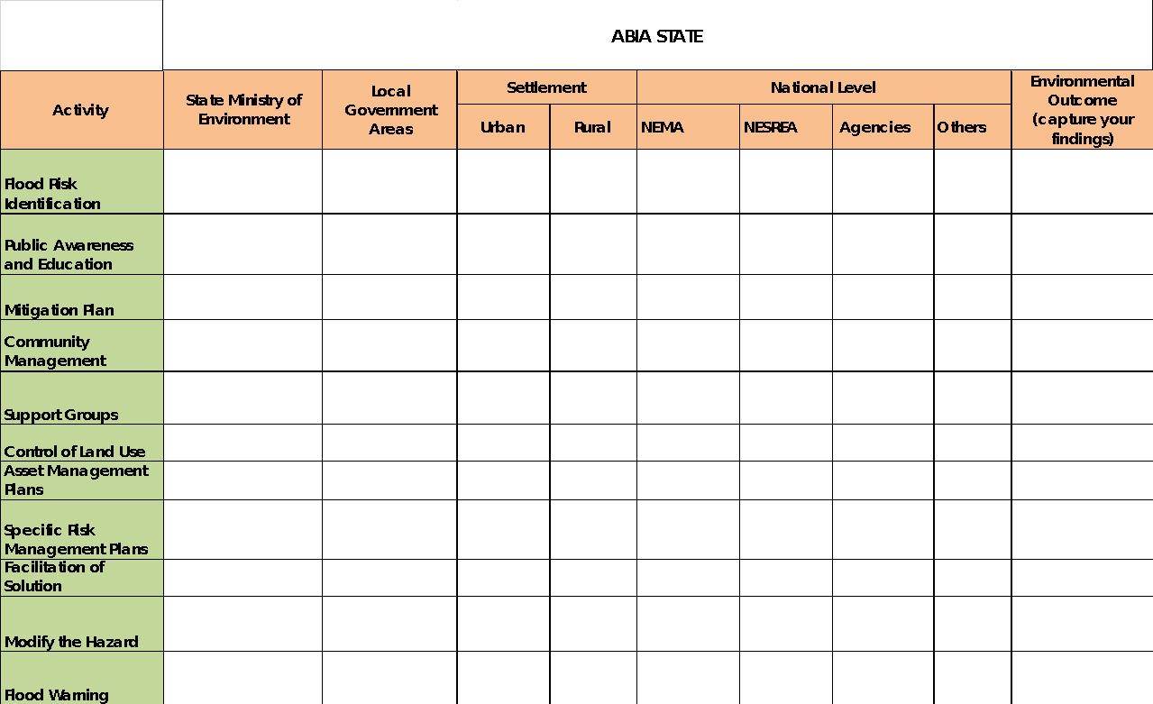

7.2 Monitoring Mitigation
Since flood mitigation requires planning and infrastructural changes his will involve asking pertinent questions that will determine the level of certain measures and actions that have been put in place to build resilience of the populace to the impact of flood. Questions such as those listed below will allow the Monitoring committee to measure the level of compliance to the flood plan as well as core mitigation activities:
- Operationalization of the Plan at Sub-national Level
- No of State and LGA’s with comprehensive and operational plans that have a hazard element or flood planning section? (including hazard mapping plan and State Contingency Plans)
- No of State and LGA’s that review building codes and town plans, and implement/enforce the regulations and standards ?
- No of Local Government Emergency response personnel, flood plain manager, and department of public works participate that were involved in developing/updating the comprehensive flood mitigation plan?
- No of States/ LGAs that have a local Hazard Mitigation Plan approved by NEMA and the Military or State Disaster Response Units?
- No of stakeholder groups such as local businesses, schools, hospitals/medical facilities, agricultural landowners, and others who could be affected by floods, that were involved in drafting processes?
- No of stakeholder groups that have been sensitized and made aware of their role and responsibilities in the both sub-national and national plans ?
- Has the community encouraged agricultural and other landowners to implement pre-disaster mitigation measures?
- Whether the affected community has adopted and owned mitigation measures?

- Infrastructural changes and enhancement to control waters : with the view that flood water can be better managed and channelled for beneficial purposes such as agriculture and electricity; is it important structural changes are made and adapted in line with the integrated flood management approach and ‘build better back’ strategies:
- No of dams, irrigation systems, sewers, drains barriers and other infrastructures developed or refurbished to control the safe passage of waters for beneficial use?
- No and scope of insurance schemes available to government, private sector and individuals to secure infrastructure, properties, and livelihoods?

7.3 Monitoring Response
When the flooding is imminent, the response to the disaster caused by the flood must be swift and immediate to avert loss of life and reduce property damage. Monitoring the response to flood disaster will involve holding state actors responsible. A response checklist will be developed which will describe summary of actions to be carried out, who is responsible for those actions and when the actions are to be executed. An example of the template can be found below, with additional indicators for guidance on what to monitor within a response.
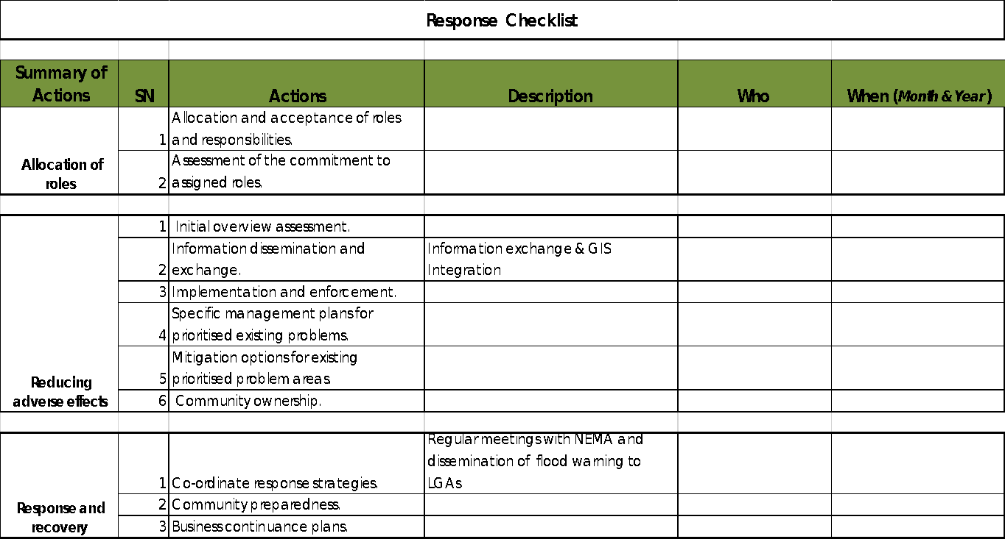

- Response Time: includes how fast emergency responders are at an emergency scene and able to render support and the seamless transition to flood management phases. It also considers strategic timeframes set out by other policies including 24-48-72 hours emergency response time; 3-month and 6-month review and transition times ( i.e. to early recovery and rehabilitation)
- How fast (in terms of tine/speed and efficiency emergency risk information and incident report reached the relevant coordinating body and responding agencies ?
- How fast/time and speed the response agency used to reach affect communities?
- Time it took for equipment and logistics to reach affected locations/communities?

- Profiling of response equipment
- Whether equipment was functional and effective in the response?
- Whether the most efficient (based on local context) response equipment have been used ?

- Effectiveness and Impact of the Response and Stakeholders Capacity.
- Whether the response has made an impact in saving lives, and protecting properties and the environment from further destruction?
- Whether lessons learnt from pass response have been used in planning the response?
- Whether the 5 W’s and H have been used in the assessment of the response
- Which stakeholders have participated in the response and whether their participation was with full capacity?
- Whether an impact assessment has been conducted on the response?
- Whether feedback mechanisms have been utilized from the top down-bottom up to assess the impact of the response and capacity of response agencies?

6.4 Monitoring Recovery
Recovery is the coordinated process of supporting affected communities in the reconstruction of the built environment and restoration of emotional, social, economic and natural environment.

Monitoring the recovery of areas affected by flood should involve monitoring activities deployed to achieve the desired recovery objective and outcome after the occurrence of a disaster. This should include Government sponsored recovery programmes that are focused on bringing back the community to pre-event conditions where they can return to normality.

There are critical key issues that are overlapping and should be performed throughout the recovery processes such as building better back (building resilience of communities and building sustainable infrastructure); the roll out livelihood support and empowerment programs and interventions; and the provision of psychosocial support etc.

Recovery can be further divided into 3 phases: namely early recovery; mid-term recovery and long-term recovery. Below is a list of recommended indictors for monitoring recovery measures:

Early Recovery
- Whether there was an assessment of the needs of flooded communities?
- Whether response and recovery stakeholders have facilitated the clearing and sanitation of affected areas?
- No of disease surveillance and health check-ups that has been conducted on both persons and the environment?
- No of operational development plans and strategies developed for the reconstruction of infrastructure?
- No of persons/households reached with psychosocial support?
- Whether there is continuous engagement with stakeholders at all levels in the monitoring of outcomes of response and planning recovery programmes ?
- No of national programmes or interventions (i.e. social investment schemes) modified to cater to the emerging needs of the flooded communities ?
- Whether non-performing programs have been identified and modified early in the recovery efforts ?
- Whether resources have been redirected to other areas of need after earlier targets are achieved?
- Whether progress on recovery has been communicated to the community and other relevant stakeholders ?

Mid-Term Recovery
- No of states involved (with technical support and financial part-funding) in reconstruction efforts?
- No of recovery progress reports developed with key findings of monitoring exercises.
- No of reports outlining key indicators and qualitative assessment of recovery activities and recovery progress?
- report on ways the local community has been involved in the recovery process.

Long-Term/Post Recovery
- No of Recovery Progress Reports with lessons learned from the evaluations of all phases of the response ?
- No of persons/households returned and resettled ?
- No of resilience programs and interventions linked to preparedness and mitigation phases ?

CHAPTER EIGHT

8.1 RECOMMENDATIONS
After sharing of ideas and experiences across Multi-Sectorial Stakeholders, the Inter-ministerial Flood Technical Working Group is recommending the following:
- Upon approval, this Inter-ministerial Flood Technical Working Group intends to draw Flood Emergency Plan Guidance & Template to guide the implementation of the National Flood Emergency Preparedness and Response Plan at different levels
- The Federal Ministry of Humanitarian Affairs, Disaster Management and Social Development (FMHADMSD) should play a leading role to ensure that all relevant stakeholders are proactively engaged in achieving the objectives of the plans; through programs, advocacy, education (trainings) and awareness
- FMHADMSD in collaboration with relevant agencies under her shall coordinate, supervise and facilitate the monitoring of all activities/strategic plans on Mitigation, Preparedness, Response and Recovery plan
- Inter-Ministerial Committee on National Flood Emergency Preparedness and Response Plan should lobby and use other governmental mechanisms to get the buy-in of Sub-National Governments for effective take off and mainstreaming of the plan in their respective States
- The Inter-ministerial Flood Technical Working Group should be involved/consulted in the preparation of annual budget for the execution of the plan in phases of the National Flood Emergency Preparedness and Response Plan in Nigeria
- In preparation for annual floods, the Inter-Ministerial Committee FMHADMSD or state government (via SEMA) shall host/attend/supervise an annual stakeholder consultation and meetings (in States/geopolitical zones/local). The objective of this meeting to convey stakeholders to discuss critical and new and emerging issues.
- Collaborations framework between local communities, NGOs, CSOs, UN Agencies, local and international donor organizations towards managing floods shall be established and maintained by the Inter-Ministerial Committee
- The Inter-Ministerial Committee should ensure the establishment of the National Flood Insurance Program or strengthen it, if already in existence, to ensure that flood victims are fairly and equitably cared for
- Establishing a Monitoring and evaluation mechanism through which relevant key performance Indicators (KPIs) are used to assess the performance and implementation of the Plan
- There should be adequate sensitization of people, whom are often affected by flood incidences, towards adopting environmental best practices
- Streams, rivers and covets should be channelled by deepening, widening/strengthening to allow smooth and rapid runoff
- Collective efforts must be geared towards adequate city planning, enhanced public enlightenment programs, integration of environmental planning and education to curriculum of schools at all levels
- Town planning regulations and codes should be aggressively enforced and strictly adhered to, as doing this will go a long way at curbing flood menace in the country.
- FMHADMSD to work closely with the High-Level Inter-Ministerial Committee to advocate for the strengthening and reinvigorating the Nigerian Agricultural Insurance Company to be properly positioned in covering farmers in flood prone areas.

Critical Success Factors
- To ensure successful implementation and acceptability of the National Flood Emergency Preparedness and Response Plan, it is considered imperative to convene a Zonal Validation/Consultative Workshop for the purpose of obtaining inputs from relevant stakeholders into the document.
- In corollary to the above, a Zonal Sensitization Workshop is to be convened to equip and inform the first respondents at the local level and relevant state MDAs with National Flood Emergency Preparedness and Response Plan.

8.2 CONCLUSIONS
Fundamentally, the ultimate reason for the existence of any G government in the world is to secure lives and properties, equitable and commensurate distribution/allocation of resources, welfare packages, and provision of basic infrastructure, and good Governance amongst others. Since provision of infrastructure is part of the essence of government at all levels, there is a need to assess, review and strengthen the existing infrastructures and approaches geared towards the management of floods menace, which has been an annual source of deaths and loss of properties in Nigeria.
To this end, as a responsible and responsive Government, the Inter-Ministerial Committee on National Flood Emergency Preparedness and Response Plan was inaugurated in 2020 to; increase (all level) Political and Stakeholder commitment, participation and Governance of flood Risk Reduction. Furthermore, to improve local capacities for the identification, mitigation, prevention, response, assessment and monitoring of flood risk ravaging most, if not all 6 Geo-political zones in Nigeria.
Furthermore, this report has painstakingly assessed flood experiences in Nigeria from 2012-2018, the types of flooding, causes and its impact on development which has primarily guided the Inter-ministerial Flood Technical Working Group in this pursuit. The Stakeholder Mapping section of the Plan identified and assigned roles and responsibilities to the relevant actors (Federal, State, LGA, Local Communities, UN Agencies, Development Partners/Donor, National and International CSOs and NGOs) involved in the mitigation, response, preparedness, and recovery from flood. This is aimed at ensuring accountability and openness.
Finally, the proposed Flood Fund will complement the existing Ecological Fund towards addressing the hydra-headed flooding issues in Nigeria. This has given the Inter-ministerial Flood Technical Working Group the impetus to adopt an emerging Global Model of “Flood Insurance” for communities in Nigeria.

REFERENCES

- Sendai Framework for Disaster Risk Reduction 2015 – 2030
- National Contingency Plan, 2019-2020
- National Disaster Response Plan
- National Disaster Management Framework
- Guyana National Flood Preparedness and Response Plan
- The National Flood Emergency Framework for England
- Emergency Response and Early Recovery Assistance for Flood-affected Population in Kenya-Concept Note
- Search and Rescues and Epidemic Evacuation Plan for Nigeria

